The Anatomical Geometry of Muscles Sets
This chapter will consider a concept that will be called muscle set and the way that muscles control movements through muscle set. For present purposes, muscle set will be the lengths and directions of the muscles that bind together a collection of bones. Strictly speaking, there need not be bones. For instance, the muscles of facial expression are a set of interdependent muscles that move skin and fascia. However, we will concentrate upon muscles that attach to bones and move those bones upon other bones, in joints between the bones. We start with the observation that muscles connect bones and move them relative to each other.
Muscular attachments to bones are consistent from body to body, being particular to the muscle and the bone. Therefore, muscles appear to be definite anatomical entities, rather than simply mental constructs that help us to describe their anatomy. This consistency suggests that their particular arrangement serves a purpose, which is implicit in their anatomy.
Since bones are rigid, the locations of the muscular attachment sites upon bone remain fixed relative to the placement of the bone. Consequently, as location and orientation of a bone change, so do the locations of its muscular attachments. If two bones are linked through a joint or a series of joints, then movement in a joint (or joints) will change the locations of the muscle attachments in a predictable way. That will change the lengths and directions of the muscles. If we know the locations of the muscle attachments relative to the bones and the placements of the bones, then it is possible to compute the set of muscle lengths and their directions. There will be a unique set of muscle lengths for each and every placement of the bones.

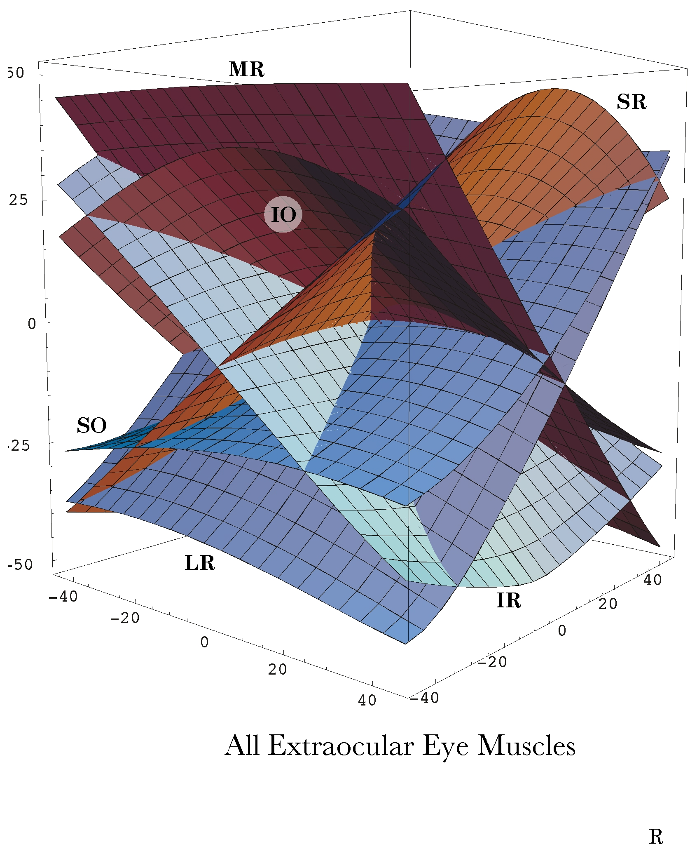
The muscle set for all the extrinsic eye muscles versus placement (gaze direction).
The set of muscle lengths can be plotted against the bony placements. The result is a surface in an abstract space. An example of such a surface is illustrated above for the extrinsic eye muscles that move the eyeball in the orbit. Such a surface has the dimensions of the bone’s, or in this case the eyeball’s, placement plus the muscle’s lengths. In the illustrated surface, lengths of the eye muscles are plotted against gaze direction.
As with many movement systems, the internal constraints of the anatomy and functional restrictions dictated by physiology reduce the number of placement dimensions, from a possible theoretical number of six (three for location and three for orientation), down to two (up/down and medial/lateral). There is an anatomical dimension for each muscle length, each of which is plotted a separate section of the surface in the illustration. The number of dimensions for the muscle set surface is the number of dimensions for placement, in this case two dimensions. In other systems the surface may have three or more dimensions. That surface is embedded in a space with a dimension for each muscle plus the number of placement dimensions. For example, the muscle set for the extrinsic eye muscles forms a two-dimensional surface in an eight dimensional space. A similar surface may be generated for any muscle set.
In this chapter we will examine how the muscle set depends upon bony placement and vice versa. In particular, we wish to examine how the disposition of the muscles affects movements that occur between bones and how the movements between bones lead to interdependency between the components of the muscle set.

A Simple Muscle Set
The following figure illustrates a simple anatomical arrangement that will serve as a model system. It involves two bones, A and B, linked by a set of muscles named for their attachments. The bones have three processes (V, L, R) that are directed symmetrically away from the center of the bone (C). The centers of the bones are linked by processes that extend into a joint between the bones (J). The lengths of the processes to the joint are not necessarily equal. In fact, one of the parameters that we will vary will be the relative distances from the bone centers to the joint (and ). Muscle attachment may be situated on any of the processes or the center of the bone.

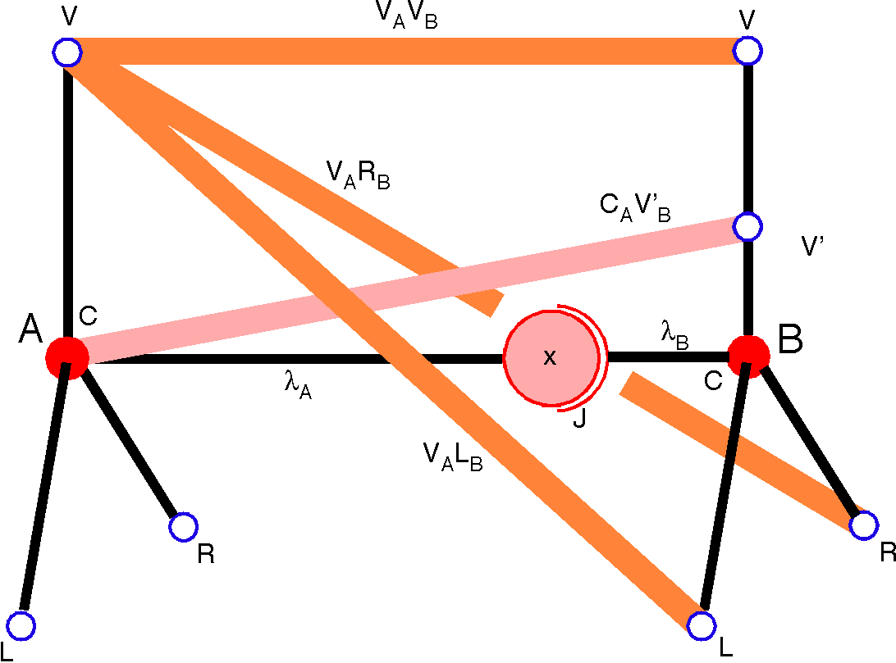

A musculoskeletal system is defined by the geometry of the component bones and the manner in which its muscles attach to those bones. The distribution of the muscles relative to the joint determine their actions.
Some sample muscles are illustrated. For instance, muscles may extend between the end of the vertical process () of bone A and the ends of any of the processes of bone B (). The muscle between the vertical processes is called , which tells us that it connects the apex of the vertical process of A () to the apex of the vertical process of B (). Similarly, the other two muscles are designated by the names and . A muscle from the center of A, , to an attachment part way up the shaft of the vertical process, , is designated by the name .

Geometrical Anatomy of a System
The origins and insertions of each muscle and the arrangement of its bones define a musculoskeletal anatomical system. Such a system may be as small a pair of bones with their muscles or a complex assembly of bones and muscles. Often the system will contain other elements, such as ligaments, joint capsules, and/or fascial sheets.
Both the origins and insertions may be referred to as insertions, because either can be fixed with the other moving or both may be moving. When we wish to explicitly state that one end of the muscle is fixed, then it will be called the origin. This is at variance with standard anatomical practice, which places the origin nearer to the body midline, irrespective of its functional role.
Muscle attachments will usually be expressed as extension vectors in framed vectors of bones. Other possible extensions of a bone may be its joints and any fulcra for muscles that may exist. The set of framed vectors that contain this information form the mathematical description of an anatomical system, its basis. The basis and a set of muscle lengths determine the geometrical anatomy of the system. With that information, we can compute the consequences of muscle actions.

Joints
In most anatomical systems a joint may reasonably assumed to have a single instantaneous axis of rotation, which may, however, shift its location relative to the participating bones as a function of joint angle. For instance, the instantaneous axis of rotation for the ulna-humeral joint rotates as a function of joint angle. That is illustrated by noting that the ulna is parallel to the humerus when the joint is fully flexed, but it generally lies at an angle to the humerus when the joint is fully extended. The angle in full extension is called the carrying angle.
It should be noted that not all joints have a single instantaneous axis of rotation. For instance, a saddle joint will have two distinct axes of rotation, which are mutually orthogonal and on opposite sides of the joint surface. There are also joints in which the joint is divided into two or more parts, which are separated by a disc within the joint. The sternoclavicular joint and the temporomandibular joints are instances of such joints. An articular disc may interact with the bones on each side of the joint in much the same way or in rather different ways. In fact, such discs are often saddle shaped which means that the two sides of the joint have different axes of rotation. Muscles acting across such a joint may have different effects depending on the state of each component joint. In effect, we have two interdependent joints, each with its own muscle moments. However, since such joints are usually small compared with the muscles acting upon them, it is often feasible to collapse the compound joint into a single complex joint.

Anatomical Joints versus Functional Joints
It is necessary to differentiate between anatomical joints and functional joints. An anatomical joint is the physical structure, usually a cleft between bones, with articular surfaces where they abut and/or they are tethered together by ligaments and/or joint capsules. The anatomical joint is interesting and important to understanding the movements between the bones. However, because the articular surfaces are nearly always curved surfaces, the axes of rotation are usually outside the anatomical joint. The placement of the axis of rotation defines a functional joint. In the lower cervical spine, the axes of rotation for a joint may be several vertebrae caudal to the anatomical joint, which may place the functional joint entirely outside the bones of the neck (see chapters on the cervical spine).

Muscle Moment
The muscle moment, , is the ratio of the muscle’s insertions (A, B) relative to the functional joint (J) across which they are acting (). It is a quaternion, with a vector that passes through the joint, perpendicular to the plane that contains the joint and both insertions. Where an attachment has been designated as the origin, the ratio will usually be the origin over the insertion, because that is the direction in which the muscle is rotating the moving bone.

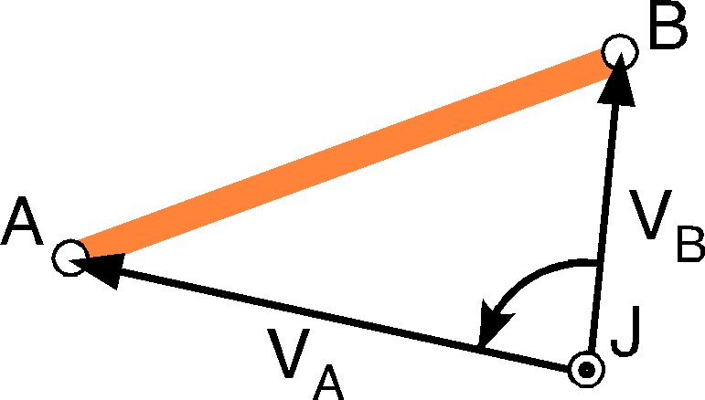

A muscle’s moment is the ratio of it origin to its insertion, where both are defined relative to the joint that it is operating across.
The angle of the moment ( or ) is the angular excursion from B to A, viewed from J. The vector of the moment is perpendicular to the plane of the vectors and . The tensor of the moment ( or ) is the ratio of the distance from J to A to the distance from J to B. We will often throw away the tensor by using the norm of the muscle moment, the unitary muscle moment, . Often, we will be primarily interested in the vector of the muscle moment, .
Muscle moments reflect the turning ability of the muscle acting at the joint. It may be easily seen that the angle of the muscle moment is a function of the muscle’s location relative to the joint (see next figure, below). For instance, a muscle that lies close to the joint will produce greater amounts of angular excursion than the same length muscle are a greater distance. However, the more distant muscle will move the joint more readily with the same effort, as dictated by the geometry of levers (Force x Distance = Constant = Work).

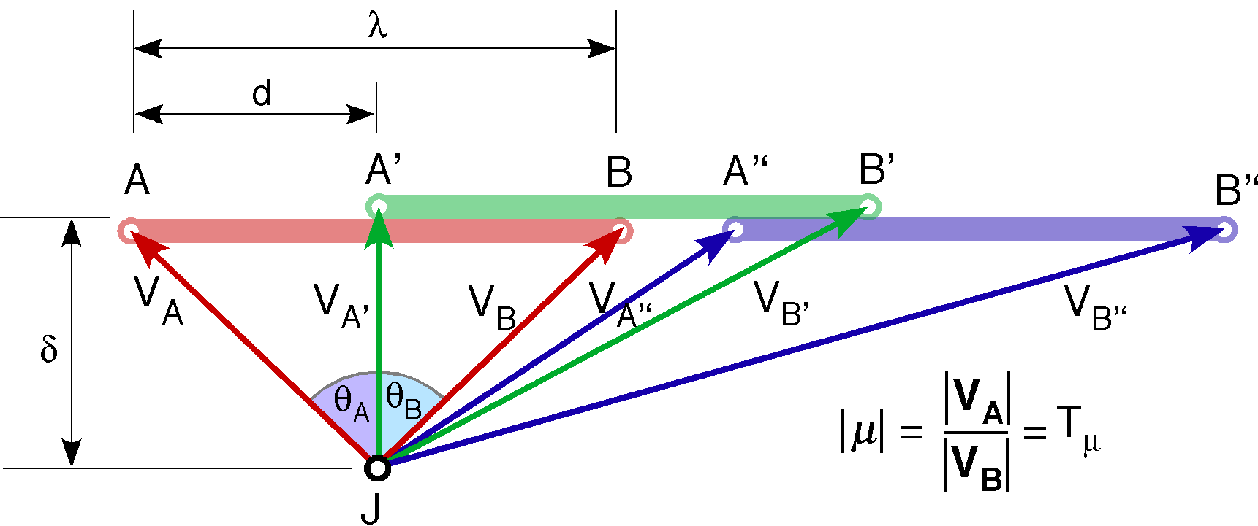

The same length muscle is shifted between three positions along a single direction. The red version (AB) is symmetrical relative to the joint, the green version (A´B´) is positioned so that the A end is directly opposite the joint, and the blue version (A´´B´´) is some distance away from the joint. All three versions are a distance δ away from the joint in a direction that is perpendicular to the direction of the muscle. The muscle has a length of λ and the AB muscle is shifted a distance d from the perpendicular to the muscle though the joint.

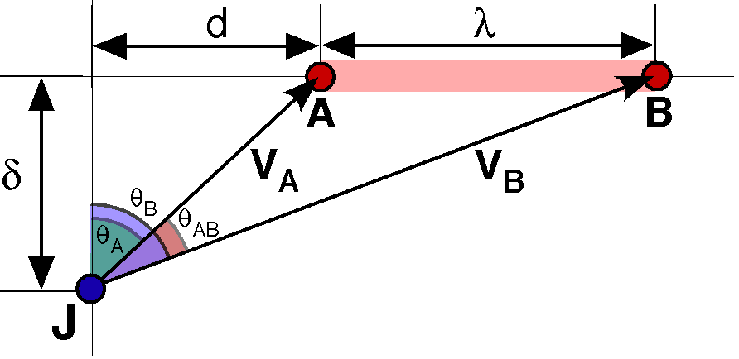

The location of the muscle relative to the joint determines the tensor of its moment in a non-linear fashion.
The placement of the muscle relative to the joint along the axis of the muscle may also affect the muscle moment. If the muscle is symmetrical with respect to the joint, then the lengths of the insertion vectors will be equal and the moment will be a unit quaternion. If the muscle is aligned so that one insertion is as close as possible to the joint, then the relative lengths of the insertion vectors will be as great or small as possible. If both insertions are distant from the joint, then the tensor of the movement will also be approximately unity.
The tensor of the muscle moment is the ratio of the lengths of the vectors to the muscle insertions.

If we assume a muscle length of 1.0 () and vary the distance to the line of action of the muscle () and the displacement of the origin of the muscle (d), then the tensor varies in the manner illustrated in the following figure. For the muscle close to the joint, , the behavior is much more non-linear than for the muscle moderately distant () or distant (). The relationship is most sensitive for situations where the muscle extends to either side of the joint ().

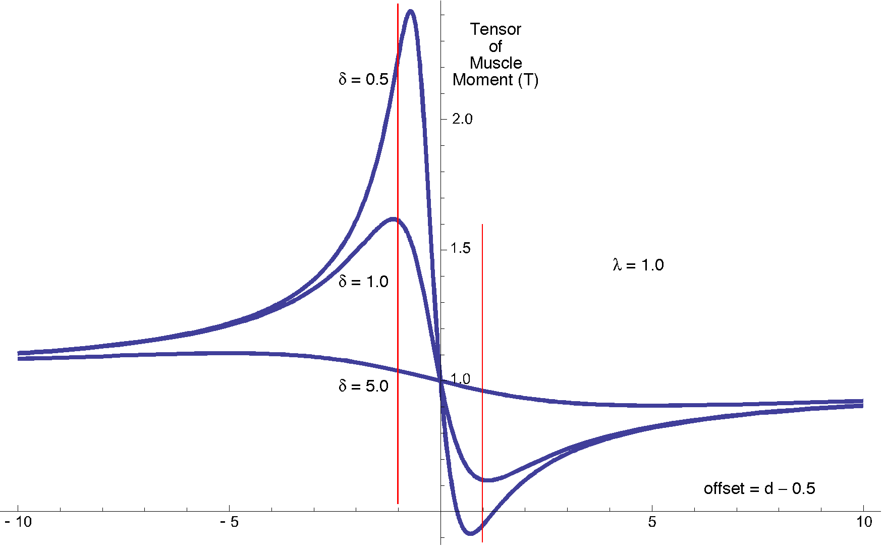

The tensor of the muscle moment is plotted versus the offset for a range of offsets and distances to the line of action from the joint. The tensor is highly sensitive to the location of the muscle relative to the joint, especially when the muscle lies close to the joint.
The tensor of the muscle moment will generally not be useful in what follows and it will be common practice to compute and use the unit quaternion for the muscle moment. For most muscles the muscle passes quite close to the joint and it attaches to either side of the joint in a highly asymmetrical fashion. That is when the tensor is apt to be approximately maximal or minimal.
The angle of the muscle moment quaternion is the difference between the two insertions vectors.

Determining the Perpendicular Distance from a Joint to a Muscle
Given a muscle that has a direction and a muscle moment
,
it is possible to determine the nearest approach of the muscle line of action to the joint, . We compute the unit vector of each parameter to determine the directions of the muscle and of the turning vector, which we know is perpendicular to the plane that contains the two insertions and the joint.
The unit vector in the direction of the perpendicular to the line of muscle action through the joint is mutually perpendicular to the already computed vectors.
We can specify the point of intersection between the perpendicular and the line of action in two different ways. It is the point A plus some multiple of the unit vector in the direction of the muscle action, , and it is the joint location plus some multiple of the unit vector in the direction of the perpendicular through the joint to the line of action, . On the other hand the insertion A is the joint plus the vector to the insertion.

If we write out the three component equations for the three orthogonal basis vectors, then there are three equations with two unknowns, therefore we can determine the value of , which is the distance from the joint to the line of action of the muscle, .

Muscle Set Surfaces as a Function of Joint Anatomy

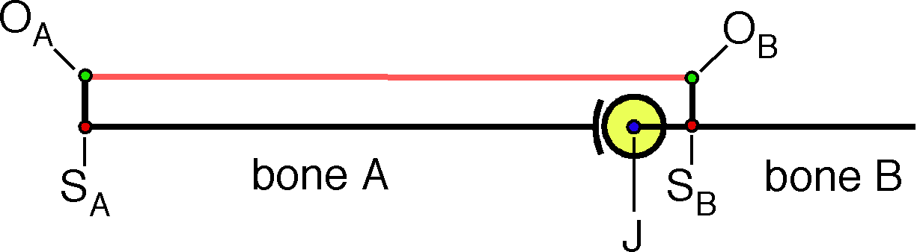
Let us envision a generalized joint, as illustrated in the above figure. It is a universal joint with a spherical joint surface, so that all types of movements are potentially possible, rather like the shoulder and hip joints. Most joints are not that free. In fact, the hip and shoulder joints are not as free to move. However, we can consider most joints as special cases of this general joint.
We introduce a muscle that connects two bony offsets, one on each bone (O_{A} on bone A and O_{B} on bone B). The offsets are attached to the bones are S_{A} and S_{B}, respectively. The functional joint, J, is located at the center of the spherical facet. The value of each of these points is a variable and specific ranges of values are characteristic of a particular type of joint. The geometry of a joint determines the special features of that joint. A large part of the fascination in studying joint lies in seeing how their geometry determines their functional character. A detailed consideration of the many possible variants is not appropriate here, because relationships between joint anatomy and joint function are complex, but a few specific examples of different types of joints will be considered below.
Our present objective is to illustrate how a muscle set surface may be computed for a set of muscles crossing a joint. To start, we need to describe the anatomy with a set of framed vectors. The first defines the three points that are illustrated on bone A along with a frame of reference for that bone. It contains a location for the bone, L_{A}, and an attachment site, S_{A}, of the offset, O_{A}. For Bone B we will use the location of the functional joint, J, as the location of the bone.

Muscle length is . It is the dependent variable of the muscle set surface. As described earlier in this chapter, the muscle moment is the ratio of the origin to the insertion, relative to the joint. In this instance, the muscle moment and its unit vector are as follows.
The axis of rotation for the muscle at the joint, , is the second element of the frame of reference for the muscle relative to the joint. The first element is the unit vector in the direction of the muscle, . The third element of the frame of reference, the perpendicular to the muscle from the joint, is the ratio of these two unit vectors.

Frame of Reference for a Bone Relative to a Muscle Attachment

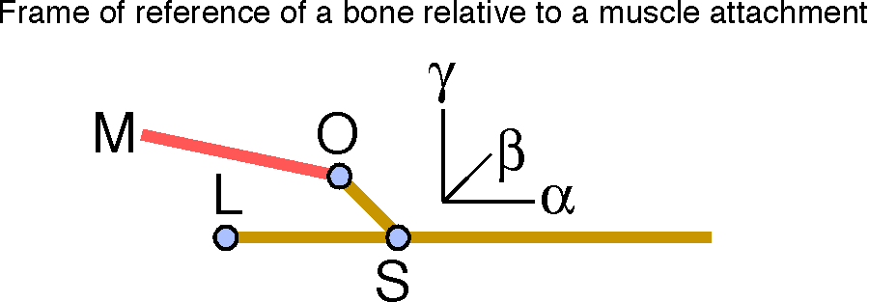

The frame of the bone relative to a muscle (M) is an ordered set of three unit vectors: 1.) in the direction of the bone shaft (α), 2.) in the direction of the axis of rotation from the bone shaft to the muscle attachment (β), and 3.) in the direction of the perpendicular from the bone shaft to the muscle attachment (γ).
In this system, let us define the direction of a bone as the unit vector in the direction of the root of the offset. In a multi-muscle system, we would have to decide on a common direction for all the muscles, but any direction that is picked may be expressed as a simple ratio to a particular direction and the root of the offset has been chosen to lie on the ‘shaft’ of the bone in the model that we are considering here. The placement of a bone will be its location and its orientation, which will be set to include the direction of the bone, the axis of rotation from the bone to the offset, and the perpendicular direction from the shaft of the bone to the offset. In the current model, the frame of reference for a bone will be three ordered vectors.
The first component is the direction of the bone, the second is the plane of the muscle attachment relative to the bone, and the third is the perpendicular direction of the muscle attachment relative to the bone.

The Muscle Set Surface is an Invariant
The muscle set surface is an invariant for the geometry of a joint/muscle system. It may be expressed in a form that does not depend upon the particular placement of the system because one can always rotate and translate the joint configuration so that one bone, say bone A, is in a standard location and orientation and then the same transformation applied to the moving bone, bone B, will bring it along in its original relation to bone A. All possible configurations of bones A and B can be realized in such a standardized musculoskeletal system. It is a canonical image of the system.
In such a canonical system, a muscle set surface can be expressed with complete generality as function of joint movements relative to a neutral placement. Muscle length is not affected by moving the system into a standard form, because internal spatial relationships are unchanged by a rotation of the system as a whole. On the other hand, muscle length varies as a function of movements from a neutral placement of the joint, irrespective of the orientation of the musculoskeletal system as a whole.
Since the movement will be the same for all muscles crossing the joint, the complete muscle set surface may be computed and plotted against the same independent variables. The complete muscle set surface is the combination of the collection of individual muscle set surfaces.
Note that muscle force is not an invariant. The muscle set for a shoulder remains the same irrespective of the orientation of the shoulder, but the forces needed to hold shoulder in a configuration may be very different, depending upon the orientation of the shoulder. The set of muscle forces required to abduct one’s shoulder 90° in standing is quite different from set of muscle forces needed to perform the same movement when lying on one’s side or back. The set of muscle forces is clearly not an invariant for the geometry of a joint/muscle system.

The Calculation of Muscle Set Surfaces
We will now consider a small number of examples of the calculation of a muscle set surface for a single muscle, plotted against relative bone placement in a joint that the muscle crosses. We will consider two simple muscle configurations and then a more complex muscle configuration, with multiple components that act differently, but in a coordinated fashion.
In each case the calculation is essentially the same. The location of the muscle insertion for neutral placement, O_{I} , relative to the functional joint, J, is computed.
The muscle insertion is rotated about the longitudinal axis of bone B, through an angle , and then about a transverse axis perpendicular to the longitudinal axis that will cause bone B to flex or extend upon bone A, through an angle . In kinesiological terminology, the moving bone spins about its longitudinal axis through an angle of and then swings about a transverse axis that moves with the bone, though an angle of . The initial transverse axis is perpendicular to the plane of the muscle and the bone, the axis of the frame of reference for the bone relative to the muscle attachment.

The muscle vector, , is the difference between the new location of the muscle insertion and the location of the muscle origin. It is the length of that is plotted versus the placement of bone B.
Rotating bone B about its longitudinal axis once more, after the computed movement, will alter the placement of bone B by changing its orientation. However, that option will not be used here. Therefore, the placement will have its orientation determined by the location and the orientation will have null spin relative to neutral placement. The advantage for present purposes is that placement has only two dimensions, allowing us to plot the muscle set surfaces as two-dimensional surfaces in a three-dimensional space.
There are other options for creating an array of placements of bone B. The one sketched here will give an array that is like the lines of longitude and latitude on a globe. In fact all of the surfaces plotted below are for a hemisphere of movement. This system seems to be a natural array for a universal joint. Other, more restricted, joints might warrant a different type of array. In which case, the rotation quaternions might be constructed differently.

A Long Muscle With Its Insertion Near the Joint
For a first example, consider a muscle like that illustrated above to illustrate the concept of a generalized universal joint, where the origin is far from the joint and the insertion is near it. In particular, let the origin be 0.2 units from the proximal end of bone A, on an offset of 0.1 units off the axis of the bone, and let the insertion be 0.1 units distal to the universal joint in bone B with an offset of 0.1 units in the same direction as the offset on bone A. The joint is constructed to have a radius of curvature of 0.1 units. Consequently, in neutral configuration the muscle has a length of 1.0 units.

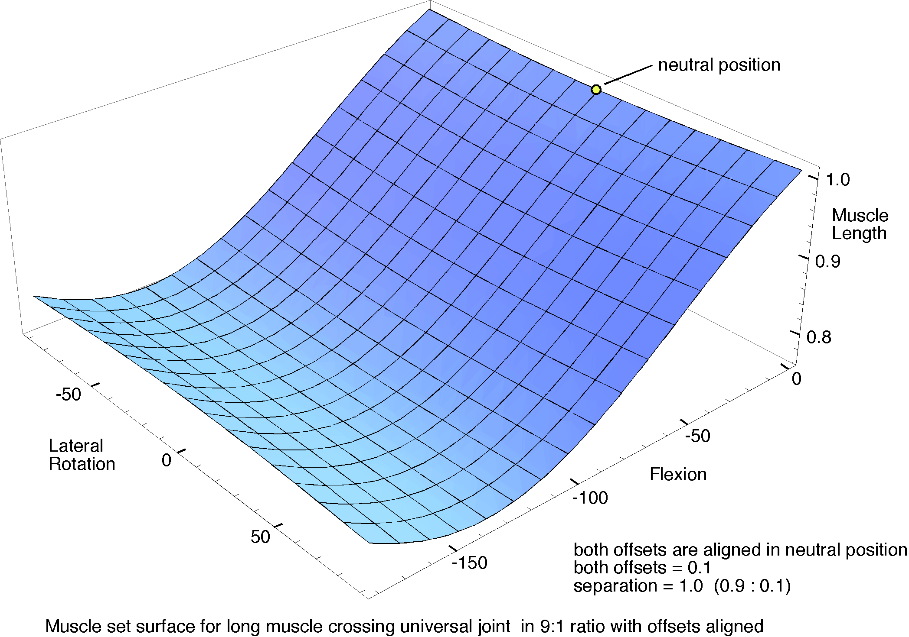
The muscle extends from an origin near the proximal end of bone A to an insertion near the joint on bone B. Both offsets are aligned in neutral position.
The muscle set surface is fairly simple. There is small concavity in the surface centered upon neutral position. As bone B is laterally rotated through 90° in either direction, there is a subtle lengthening of the muscle, so muscle contraction will have a modest tendency to bring the two offsets into alignment. However, the much greater tendency with shortening of the muscle will be to flex the joint until it is bent about 130°, beyond which the muscle will become longer with further flexion and the moving bone will tend to roll laterally. This behavior accords with our intuitive impression of what such muscles do.
This arrangement seems to be well designed for situations where a large joint excursion into flexion or extension is required. It gives large movements with modest amounts of muscle contraction. All the flexion movements converge on a common placement, just as the lines of longitude converge upon the poles.

A Short Muscle With Its Origin and Insertion Near the Joint
In a second example, the muscle origin is moved distally until it lies just proximal to the universal joint and the muscle insertion lies just distal to the joint and rotated laterally through 90°. The proximal offset is 0.1 units from the axis of the bone and the distal offset is 0.2 units. In words, the muscle wraps about a quarter of the way around the joint.
As one might expect, the muscle becomes longer as the joint is rotated so as to increase the angle between the offsets and it shortens when the angle is reduced until they are aligned. Flexing the joint also reduced the length of the muscle, but generally not as quickly. Muscle contraction that produces a rotation that brings the offsets into alignment and flexes the joint is the movement that causes the greatest shortening of the muscle. However, the extent to which the muscle can bring about that movement is restricted by the gap between the insertions when the offsets are aligned being smaller than the muscle can achieve. The maximal contraction of a muscle from greatest to shortest length is probably 50%. That means that the muscle cannot move into the nearest corner of the surface in the illustration, because the gap is on the order of 40% of that in neutral position and the muscle must be able to become longer than it is in neutral configuration if the joint is able to turn laterally in the direction that opens the angle between the offsets. Consequently, only that part of the surface that lies above 0.6 is likely to occur in a real system and the range may be substantially less.

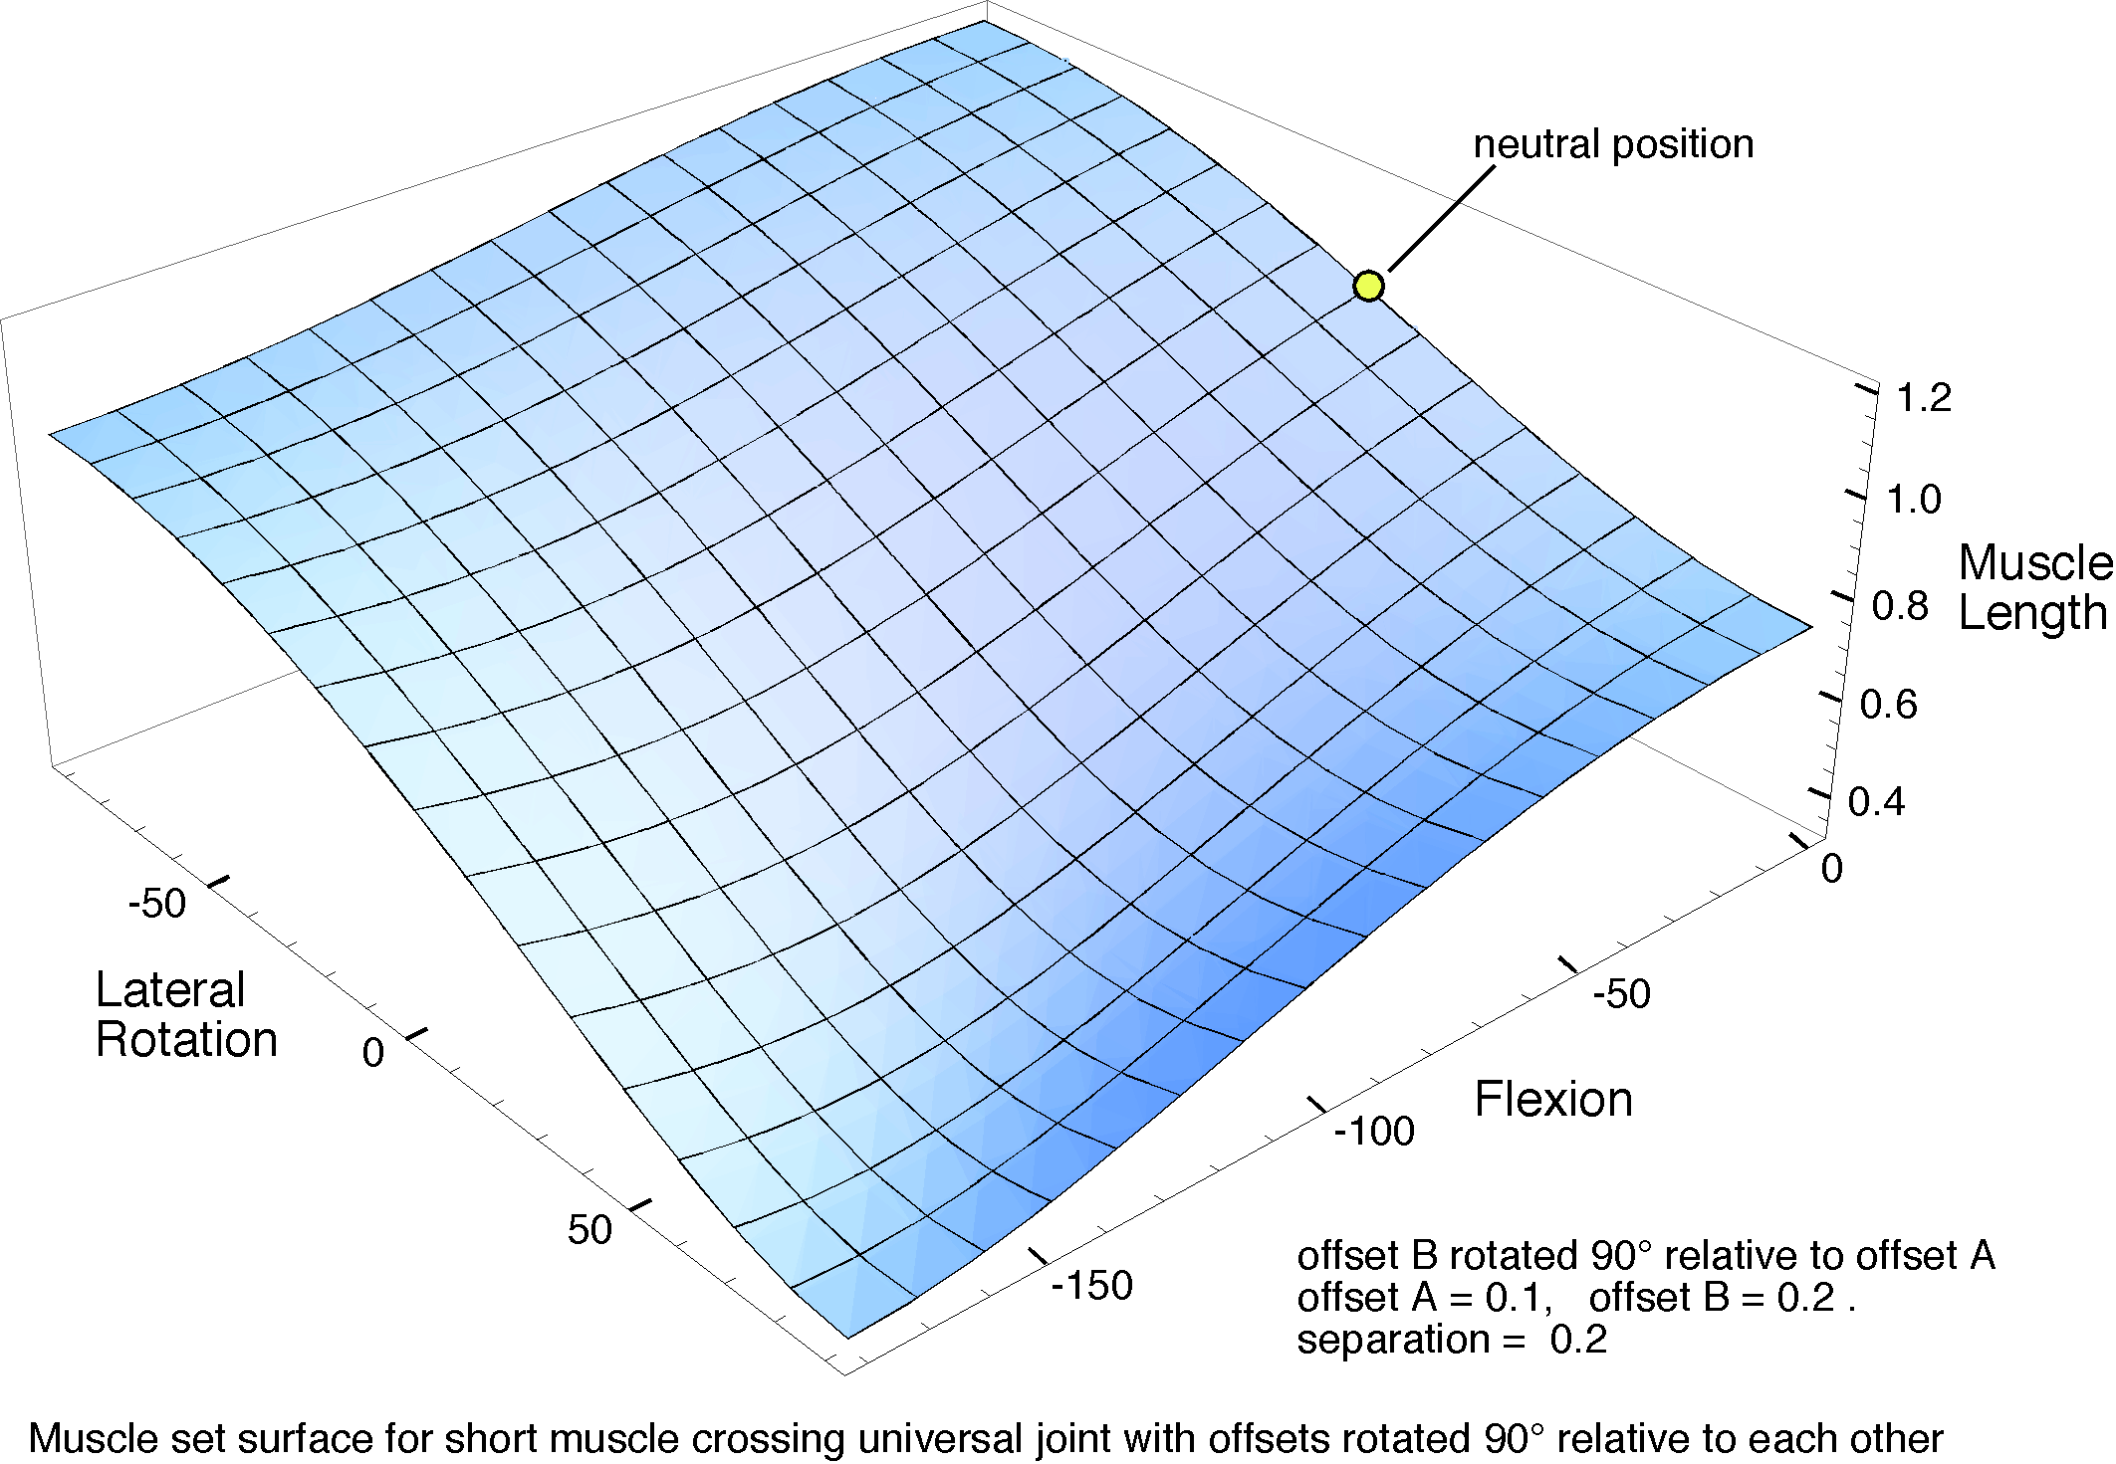
The muscle set surface for a muscle that crosses the universal joint diagonally between an origin and insertion where both are close to the joint.
As a result of these considerations, such muscles will tend to be important for laterally rotating a joint. They are most stretched and shortened by such movements and they are comparatively insensitive to flexion and extension. In this particular geometry, the amount of flexion is comparable to the amount of lateral rotation with muscle shortening.

A Deltoid-like Muscle
Next, consider a muscle that is in many ways like the deltoid muscle of the shoulder. We will consider the muscle in terms of three component muscle descriptions that represent different aspects of the muscle. The first component, the middle component, extends from an offset that directly overhangs the joint to an insertion some distance down the shaft of bone B. The joint is considered to be in neutral position when bone B is extended 90° relative to bone A. The other two components of the muscle differ in having their origins anterior and posterior to the joint as well as proximal to the joint. One might imagine the offset from bone A to have the shape of a horseshoe lying in a horizontal plane above the joint. The insertion for all three components of the muscle will be at the same point on bone B.

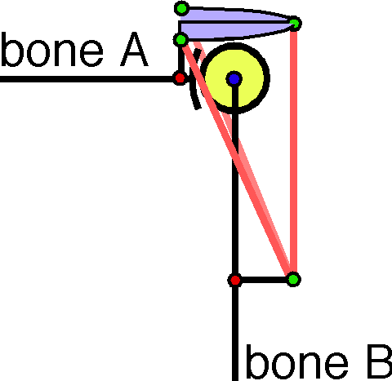
A deltoid-like muscle takes its origin from an offset ring above the joint and it inserts into the shaft of the moving bone. Three muscle components are drawn: one at the apex of the offset that runs directly down, one that takes origin anteriorly and one that takes origin posteriorly. They have a common insertion.
Bone B is rotated about its long axis through a series of angular excursions from -90° to +90° and then about an axis perpendicular to the plane that contains the shaft of the bone and the offset, again through a series of angular excursions from -90° to +90°. In each location bone B could be again rotated about its shaft, to give a variety of orientations, but that movement tends to have only a small effect on muscle length, so it is not been explored here.
In the following calculations, if the functional joint is taken to be the origin of the coordinate system, then the origins and insertion of the three components are taken to be at the following locations.

The values are approximations from actual shoulder joints, where the radius of curvature for the spherical facet is set equal to 0.1 units. One usually obtains the best results when using the values approximately equal to actual anatomical values, because they usually give the best compromise of all the possible values. By choosing values that differ from the anatomical values, one can often discover why the anatomical values are what they are.
The following figure shows the geometrical relations of the first component of the muscle. It resembles the first illustration of this section, that for a long muscle that just crosses the joint, but it is different in a number of interesting ways.
Rotation about the long axis of bone B in a pendant position leads to minor lengthening of the muscle so contraction of the muscle will tend to move the bones towards neutral configuration. That effect is more pronounced as bone B is abducted (moving towards the left in the illustrated surface). The trend is reversed when there is more that 150° of extension, however, anatomical joints would not normally support that much extension. In actual glenohumeral joints, the range of abduction is on the order of 60° to 90° of abduction and the range of medial and lateral rotation are usually less than 90° from neutral placement (Kapandji).
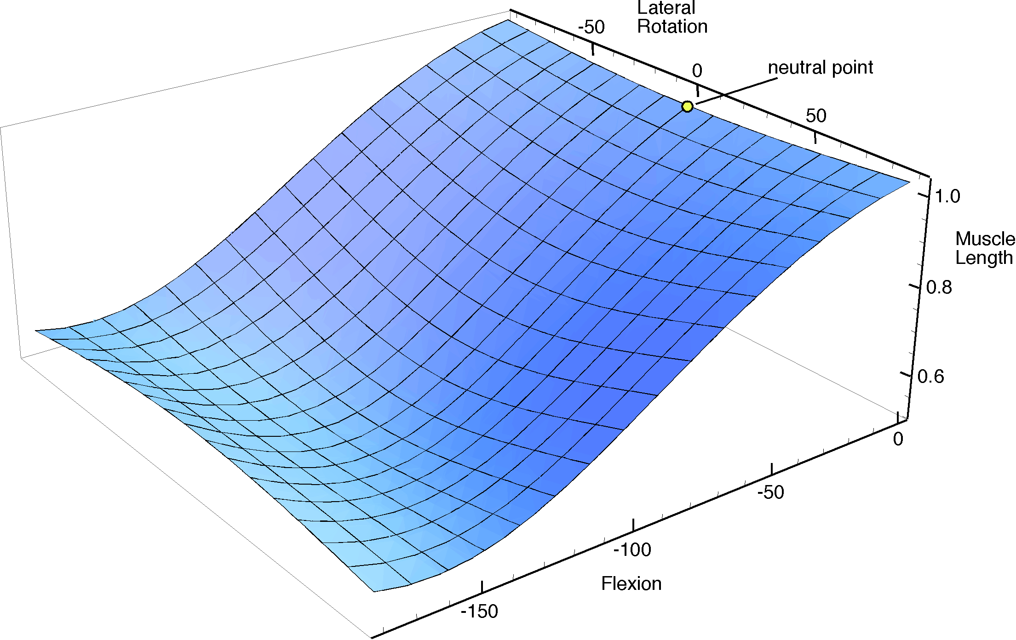

Muscle set surface for the middle component of a deltoid-like muscle where the neutral point is chosen with the arm pendant.
The more pronounced geometrical relationship is the change in muscle length as the bone B is elevated. The return on contraction becomes less as the joint approaches 150° of elevation, but it remains the dominant consequence of muscle contraction throughout the entire physiological range. Consequently, the contraction of the central component of this deltoid-like muscle, working alone, tends to lift the arm directly laterally. All the contraction vectors are directed towards the central meridian through neutral placement and elevation.
That raises the question of what one gains by having the anterior and posterior components of the muscle. Because their arrangement is symmetrical with respect to the bones their muscle set surfaces are also symmetrical.

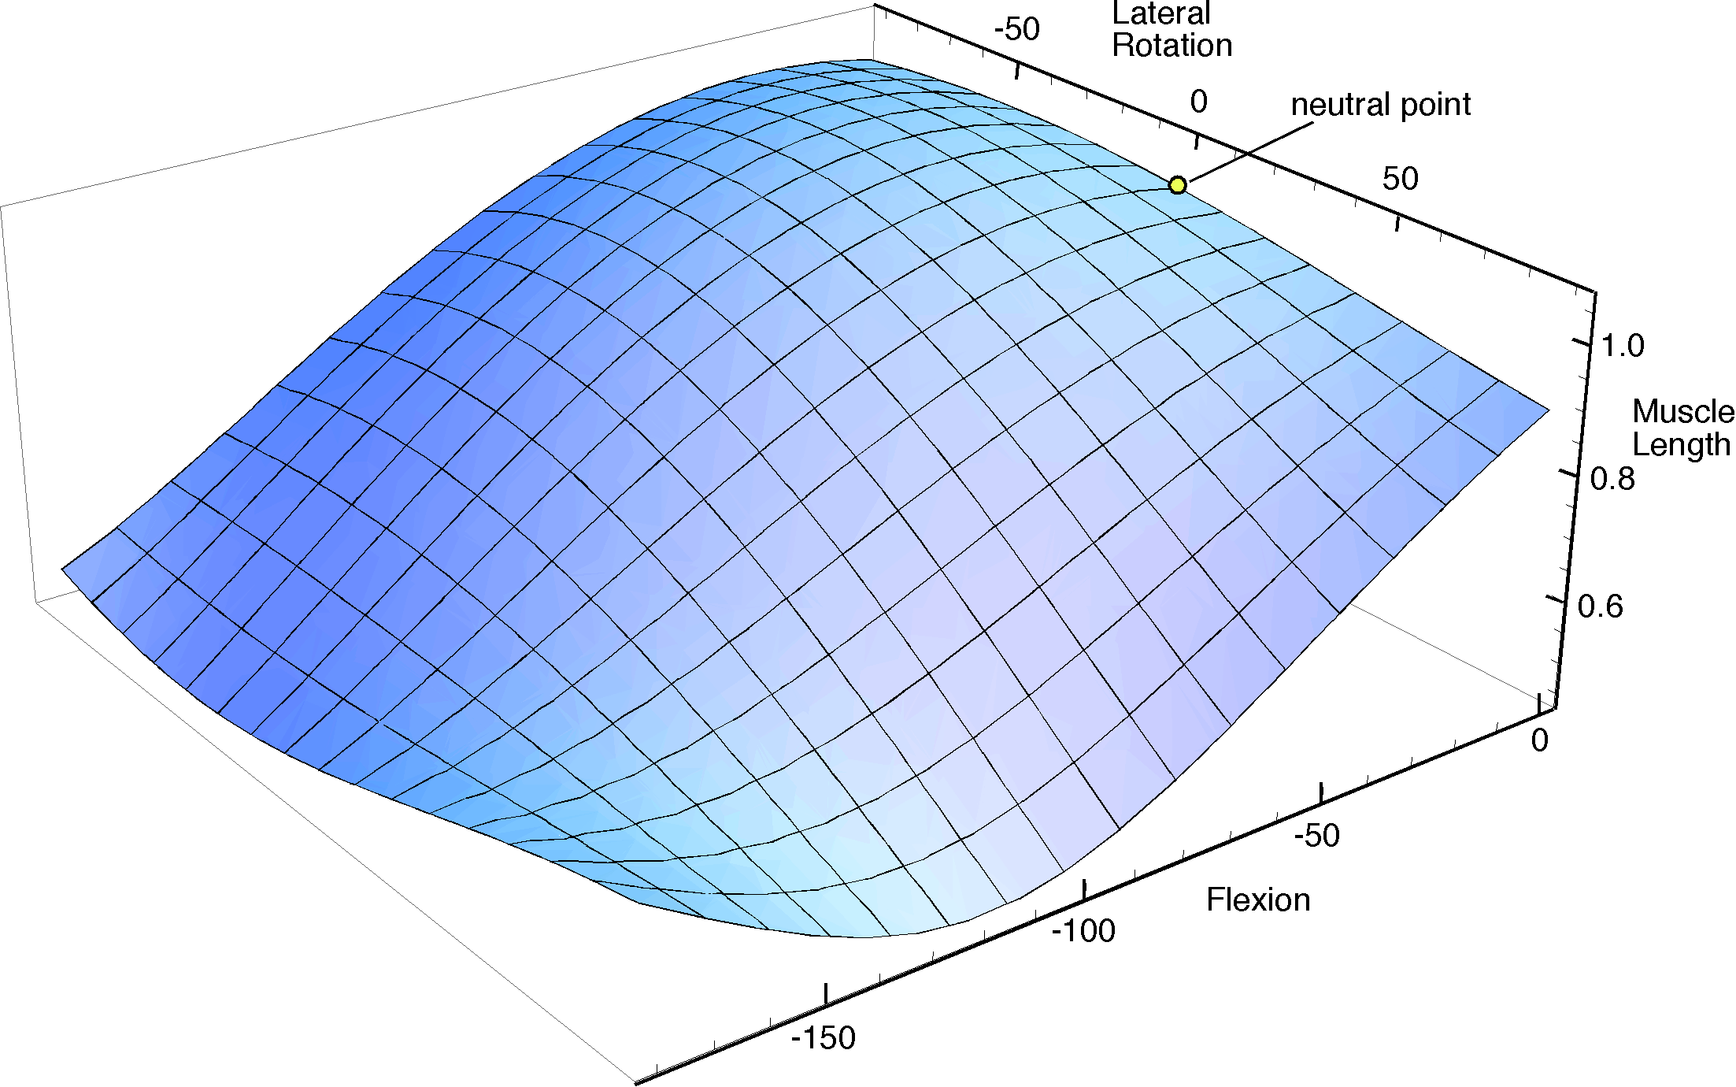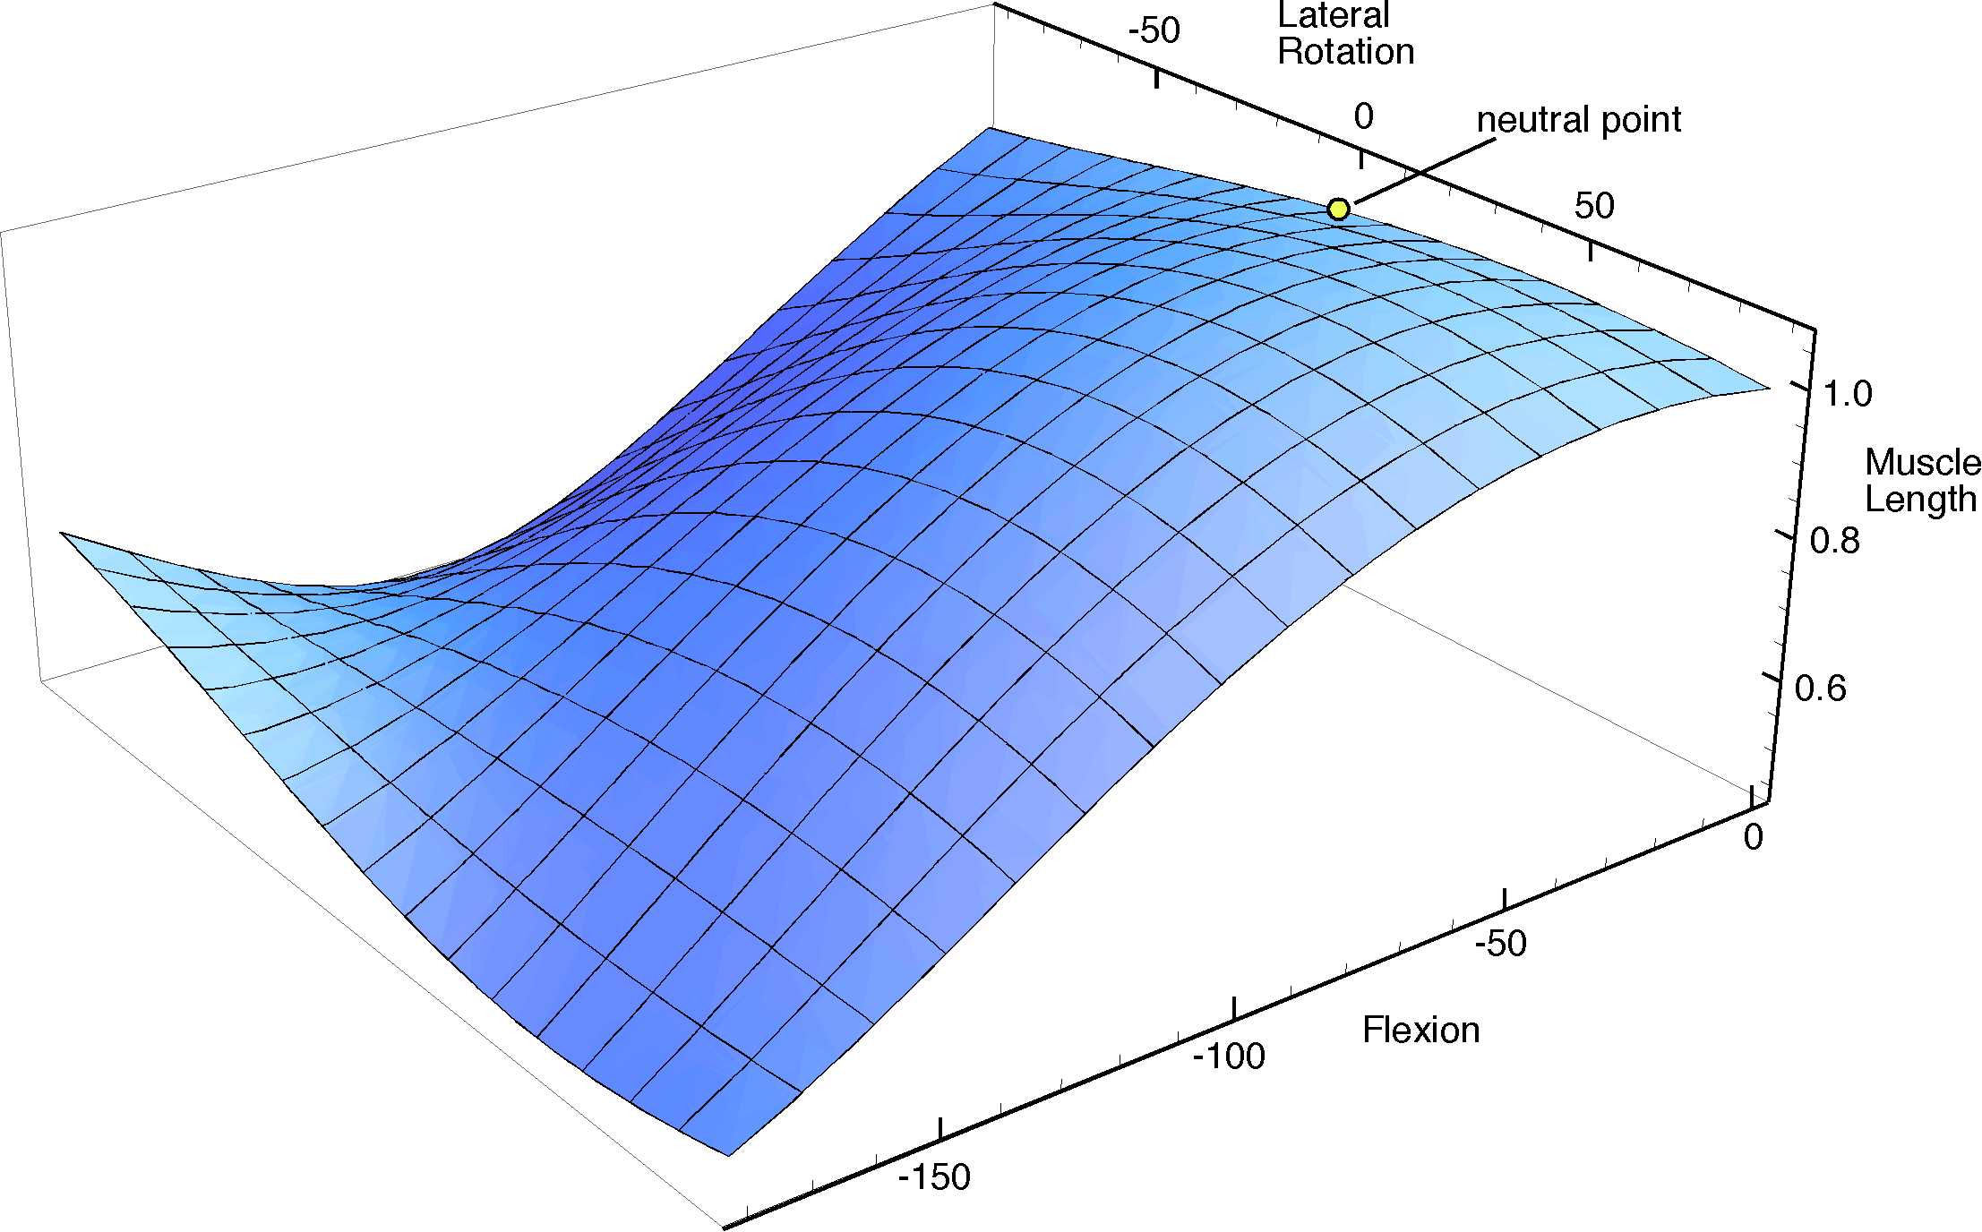

Muscle set surfaces for the anterior and posterior components of the deltoid-like muscle constrain the ability of a bone to move in the opposite direction and pull it towards the same direction at the origin. These two surfaces are mirror reflections of each other in the coronal plane through neutral placement.
The anterior and posterior components are more directed at bringing bone B forwards and backwards. Rotation of the bone about its long axis will moderately lengthen a muscle for rotation in one direction and shorten it for rotation in the opposite direction. When the bone is rotated so as to lengthen the muscle, the muscle is not very effective in elevating the bone until it is already elevated about 50°. On the other hand, when the bone is rotated so as to shorten the muscle length, the further shortening of the muscle will work to further rotate it about its axis in the same direction and to elevate it. Since portions of the muscle take origin anteriorly and portions take origin posteriorly, there is an effective aid to elevation in all directions. The portion of the muscle that is contracting will act to pull the moving bone further in the same direction. By resisting lengthening, an eccentric part of the muscle may prevent movements from moving into a substantial portion of the potential movement range. Consequently, these components may act as brakes upon movements in the direction away from their original placement.

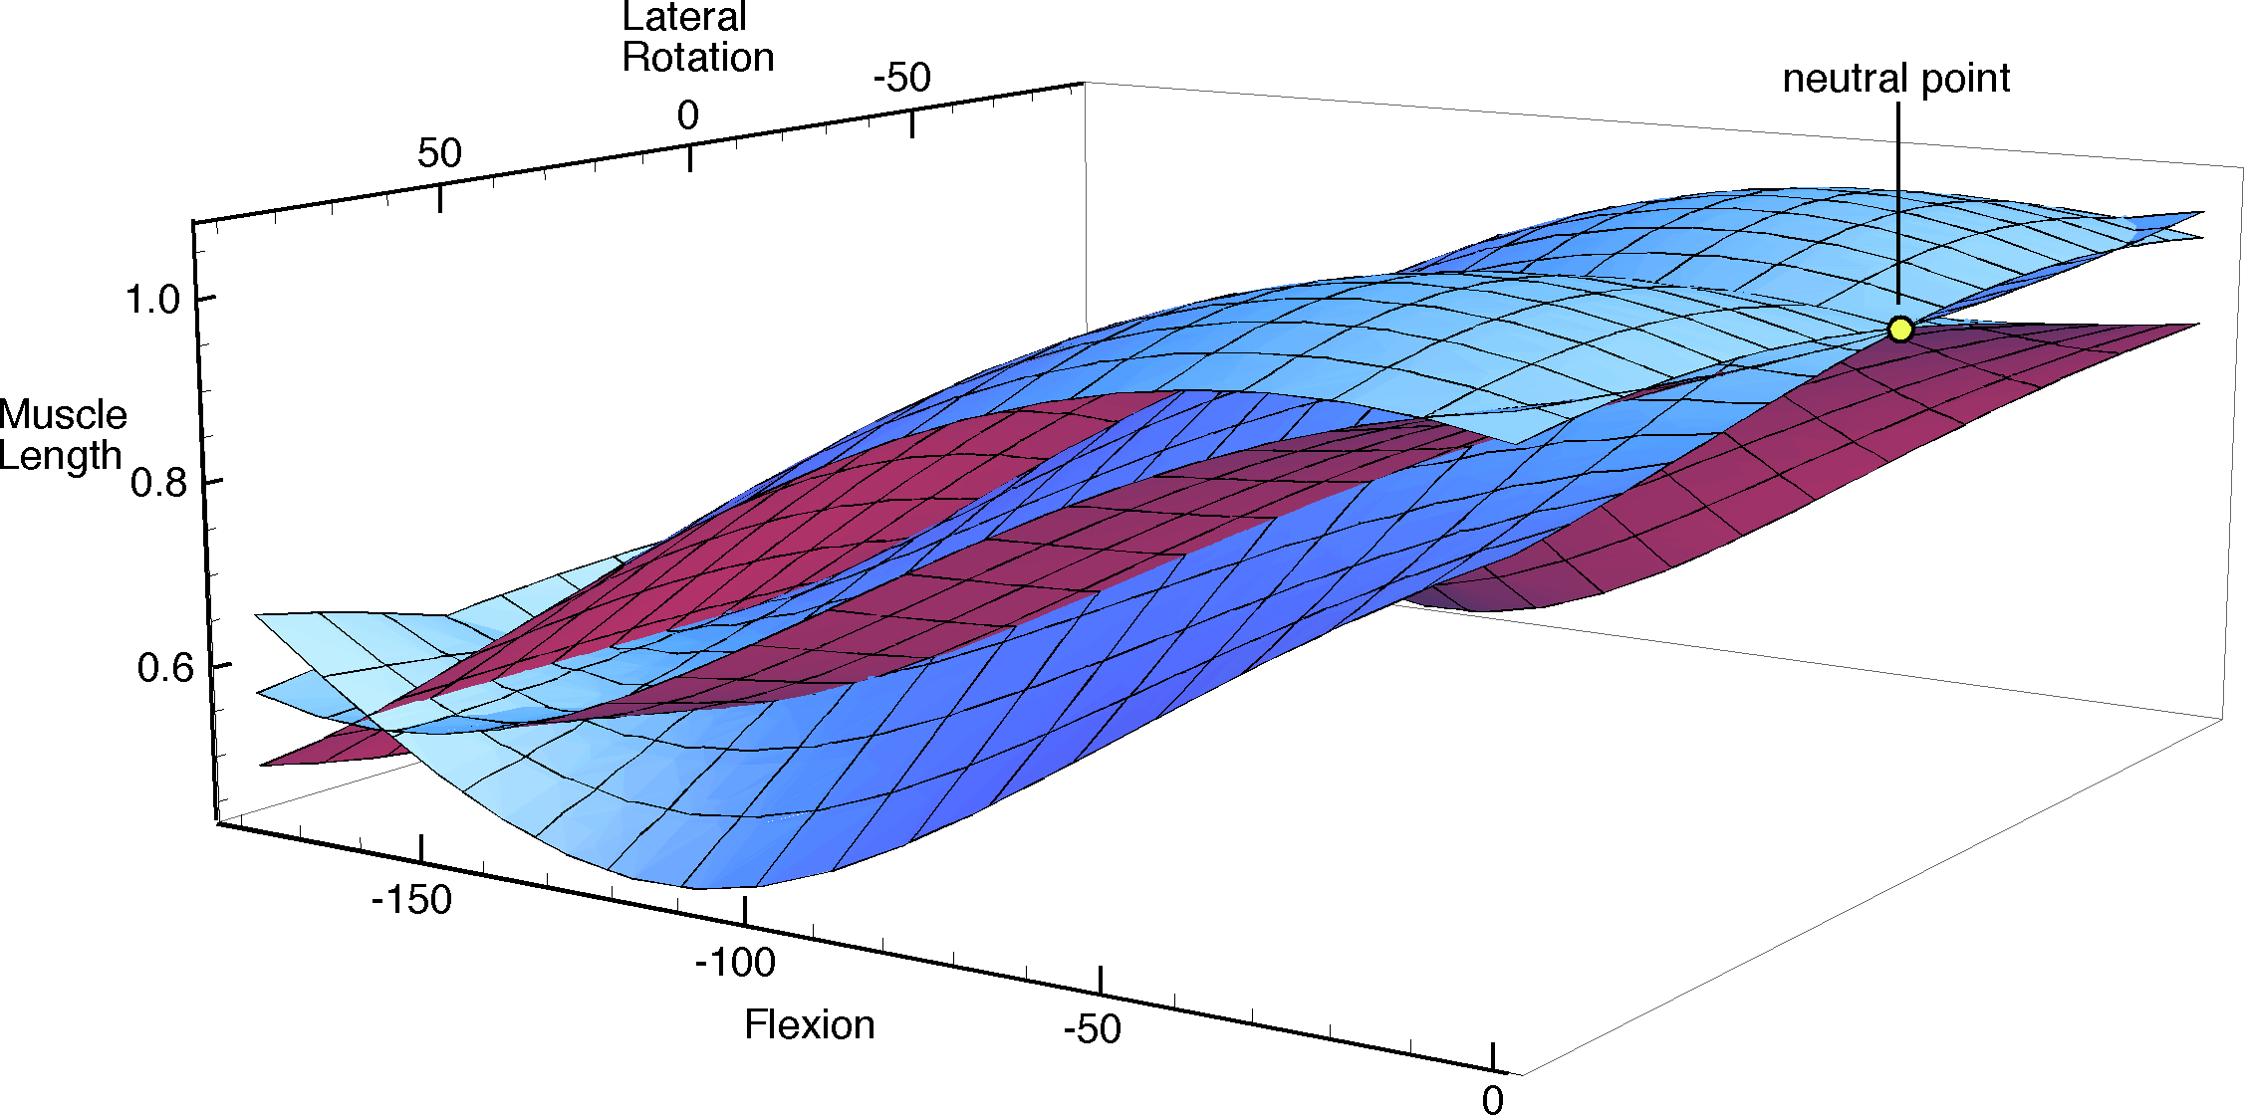
The three component muscle set surfaces considered above are plotted together and viewed from a different viewpoint.
The muscle set surface for a deltoid like muscle is complex. In the above figure the three surfaces that were considered individually are plotted in the same coordinate system to illustrate their differences and how they might work cooperatively in the control of the joint. In fact, the complete muscle set surface for the deltoid-like muscle is a stack of such surfaces, a sheave, as it were. In the figure, we see two end sheets and the median sheet in the sheave. In addition, as mentioned above, there are other options for orientation at each location of the bone, so each of these surfaces would extend into a third placement dimension, rotation about the axis of the bone. So the true surfaces are actually volumes in a four-dimensional space. Those volumes would have a three-dimensional mesh, like the lines drawn on the surfaces that are illustrated here, so that one would follow definite paths through the volume surface as the placement changed along meridians of location and orientation.
Such surfaces are complex. In most instances, three or more dimensions of placement as well as the muscle lengths for several muscles or muscle components. They are usually beyond our ability to readily visualize or comprehend in their entirety. However, with judicious simplification, one can often learn interesting things about how a muscle functions, how its geometrical anatomy influences its functioning, and why the muscle takes the form that it does. There is not space here to delve deeply into these ideas, but they warrant a separate consideration at greater length, elsewhere.

Muscle Actions

Frame of Reference for a Muscle Relative to a Joint
In the course of the derivation in the last section, we computed the three components of a frame of reference for the muscle relative to the joint. The three vectors , , and form a set of mutually perpendicular unit vectors that are related to the direction of the muscle with respect to the joint. The unit vector is the direction of the muscle, its line of action. The unit vector is the direction from the joint to the line of action of the muscle. The unit vector is the turning axis of the muscle about the joint, the axis of rotation for the muscle pulling across the joint. These are all important directions for the interactions between the muscle and the joint. Consequently, the frame of the muscle can be written as the ordered set of these three unit vectors.

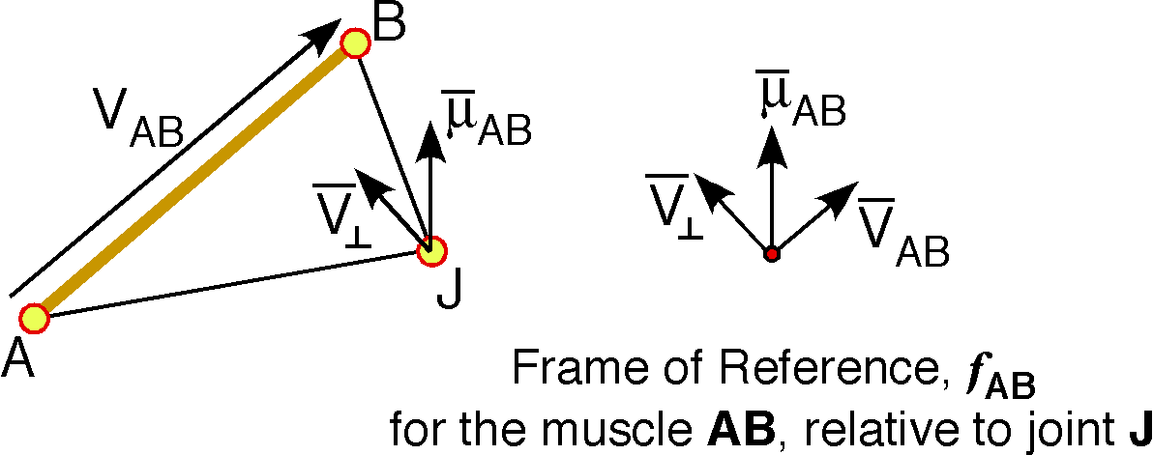

The Turning Index of a Muscle Relative to a Joint
The distance between a muscle and the joint that it is acting across will affect the turning angle that it can produce. More distal muscles will cause less rotation with the same amount of contraction. However, they are able to do the turning more readily because the product of the force and the distance is a constant, namely work. If one wishes to bring two ribs together, then the intercostals muscles, which are comparatively distant from the vertebral spine, will do so with comparatively little effort, but they do not move the ribs a great distance. A force applied to a rib near its joint with the spine is capable of much more movement of the rib with comparatively little contraction, but much more effort is required.

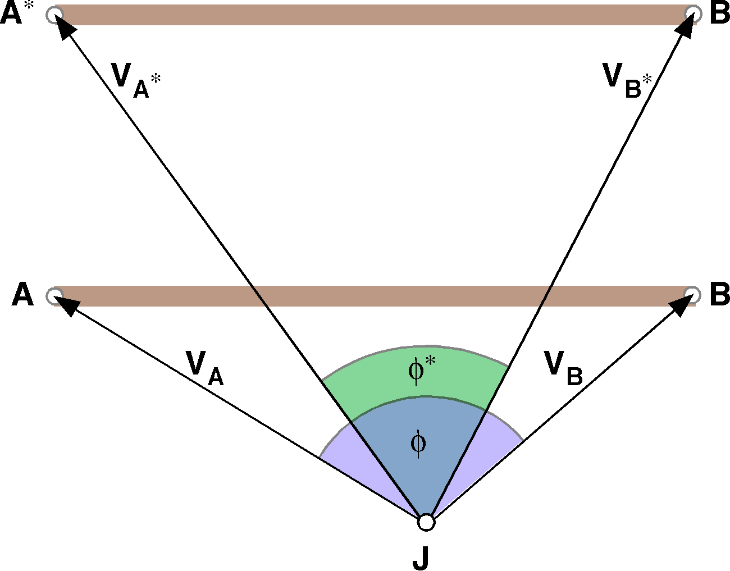

Muscles more distant from a joint will have smaller angles for the same muscle length.

Contraction Moments
A muscle that is initially of length experiences a small contraction , which moves the B end to B´. The altered muscle AB´ has a length and a direction . If the contraction is small, then one may generally use the vector of the turning quaternion as a good approximation of its axis of rotation. The actual turning moment is the ratio of the old muscle terminus to the new muscle terminus.
The instantaneous axis of rotation is .

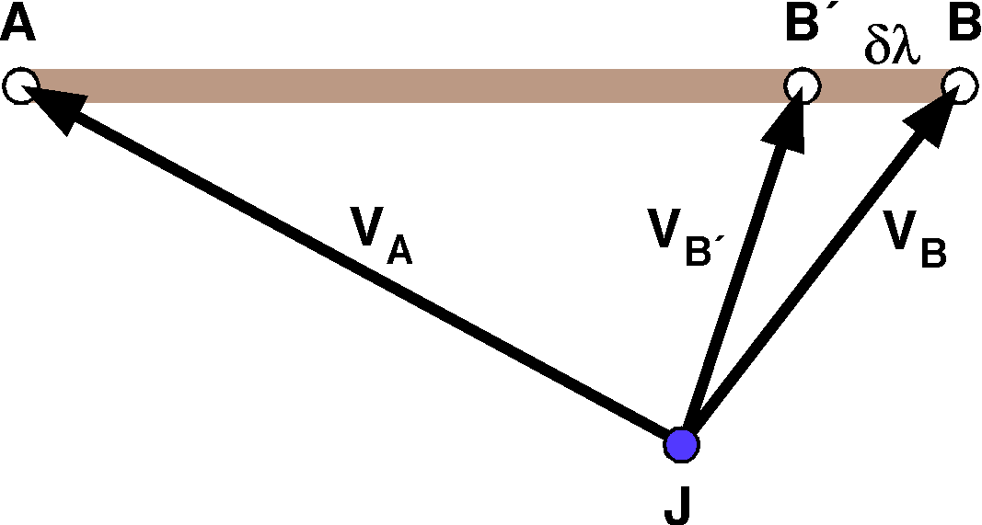
A muscle contracts from B to B´, a distance of δλ. The vectors to the insertion change from V_{B} to V_{B´} .
The reason for making the distinction is that the shortening of the muscle may move the new muscle insertion out of line with the original muscle direction. For instance, if the result of a muscle contraction is to rotate bone B, then the muscle insertion on B is also rotated and the instantaneous axis of rotation may be quite different from the turning vector for the muscle.
We can define the contraction in terms of an effort, , and an angle, , where is the angle between the line of action for the muscle, V_{AB}, and the armature from the joint to the insertion, V_{B}. The normed muscle moment times the effort may be taken to be a new entity that will be called the contraction moment of the muscle.

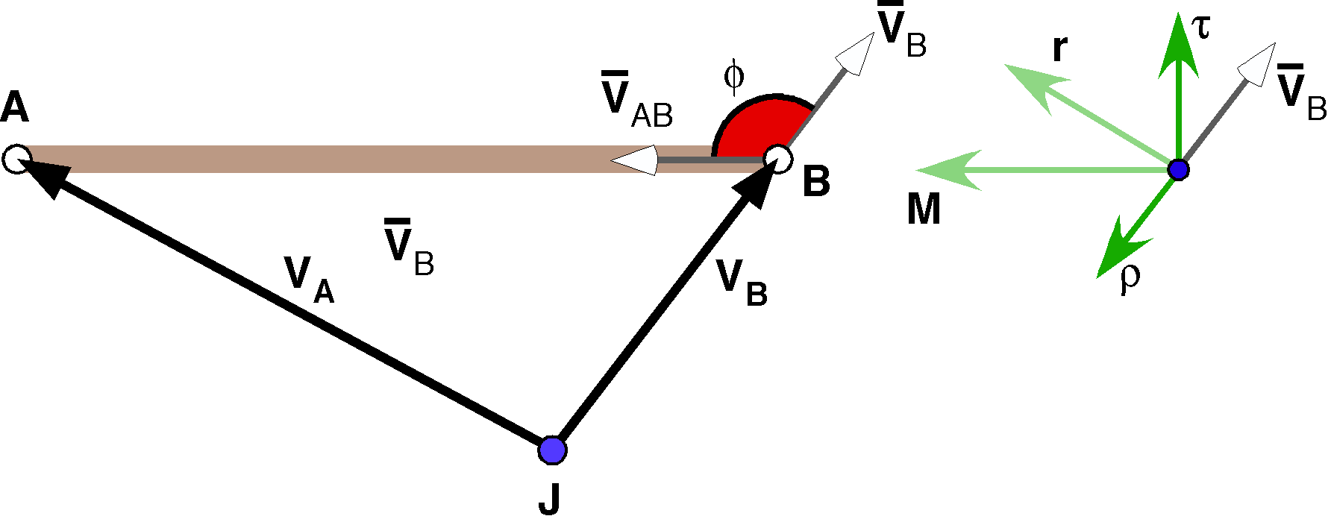

The contraction moment is a function of the effort of the muscle contraction and the angle between the muscle’s line of action and the vector from the joint to the muscle insertion. The resolution of the muscle pull into a radial and rotatory component is drawn offset from the insertion.
While the muscle moment and the contraction moment look like they should be variants of the same concept, they are quite different. The muscle moment is a geometrical description of a muscle that encapsulates its turning vector, its scope of action, and the relative locations of its insertions relative to the joint of interest. We extract the turning vector and use it as the basis of the contraction moment, which is an expression of the distribution of forces for the contraction.
Note that the vector component, , is perpendicular to the plane of the muscle and joint. It is a torque, rather than a force. Its magnitude is the magnitude of the vector that completes the parallelogram, r, but it is perpendicular to the plane of the parallelogram. The vector r indicates the force that acts to rotate the armature.
The scalar, , gives the relative effort in the direction of the armature, that is, compression or distraction of the joint. If the angle, , is less than 90°, then the action is distraction of the joint, that is, is positive. If is greater than 90°, then the action is a compression of the joint, that is, is negative. One could equally well choose the complementary angle, , in which case compression of the lever arm would be positive effort and distraction would be negative effort. The convention is set so that the force is positive when tensile and negative when compressive.
The effort is divided into a component directed along the lever arm from the joint to the insertion, which will be called the radial, compressive, or tensile impetus, and an effort in the direction of the line of action of the muscle, which will be called the rotatory impetus.
The scalar component times a unit vector in the direction of the lever arm is the radial impetus. It is a force directed along the lever arm.
The vector component of the contraction moment is the contraction moment torque times the lever arm. It is an impetus in the direction perpendicular to the lever arm and in the plane of the muscle and the joint. It causes a rotation about the axis of rotation of the joint, so, the force is in the plane of the muscle and the joint and in the direction of the right thumb as the fingers of the right hand curl from the rotation axis to the lever arm.

The term impetus is used because the quantity is proportional to the length of the lever arm, so that the same force exerted at a greater distance will more readily rotate the mobile bone. Shortly, we will render it into a force by choosing a standard length lever arm.
The vectors and are always perpendicular, because it was part of the definition of the muscle moment that is perpendicular to the plane determined by the two insertions of the muscle, A and B, and the joint, J. Because and are perpendicular, their product will always be a vector, in this case , rather than a full quaternion. Normally, the product of two vectors is a quaternion and vectors are by definition quaternions, quaternions with null scalars, but the product being specifically a vector is consistent with the product behaving as a force.
The radial and rotatory impetuses are also always perpendicular to each other, so their sum, M, is the sum of the two orthogonal vectors and it is aligned with the line of action of the muscle. The contraction moment describes the effort or a potential effort acting about a joint that a muscle is capable of producing. Potential efforts are included because, when muscle actions are combined, the actual movement produced may be different from the contraction moments of any of the competing muscles. We wish to examine the consequences of multiple muscle acting about the same joint, however, to do so, it is necessary to define one more concept.

Contraction Momentum
The contraction moment acts at an insertion to give a force pair that is the product of the contraction moment and the lever arm of the insertion relative to the joint. Let us call that product the momentum of the insertion relative to the joint, . It is a pair of vectors, expressed as a sum.
Clearly, is the same as V_{B} in the previous expressions, but we adopt it as a more general expression of the vector to the moving end of the muscle. Then we extract the direction of that vector, , for the final expression of the momentum of muscle n. The order of the product is important because we are multiplying quaternions. The given order in the definition of the momentum ensues that the axis of rotation is in the correct direction. The momentum is the sum of a force and a torque.
The momentum is a quaternion with the scalar being the force of compression or distraction operating at the functional joint and the vector component is the rotating force or the torque, also operating at the joint. The momentum is the unit vector in the direction of the insertion times the muscle contraction moment.

Moving the Contraction Momentum to the Joint
The radial force effectively acts at the functional joint, J, so we can move it to the joint and see how it would move the swinging bone upon the stationary bone. In the following figure, in panel B, the muscle pulls with a force M that is resolved into a radial force, , and rotatory force, . In panel C, the radial force, , has been redrawn as originating at the joint and it is apparent that it will tend to move bone 2 towards bone 1 and to the left to roughly equal extents.
The rotatory force, r, acts differently. It will tend to rotate bone 2 about the functional joint. The force is applied at the joint as well, but it is a product of a vector aligned with the axis of rotation for the joint, , and the lever arm, . However, we can more readily appreciate the force if we visualize it as pushing on a standard lever arm in the plane of the axis of rotation. We draw a ray that starts in the joint and extends directly away. Any ray will do, however, in this case it has been drawn down the center of bone 2. Vector indicates the direction of the ray. At a distance of one unit in the direction of we place a vector, , that extends perpendicular to the ray and which has a magnitude equal to the magnitude of the radial torque times the lever arm. The vector indicates the direction of . Because the attachment site for the muscle is less than a unit distant from the functional joint, the vector extending perpendicular to the ray is a bit shorter than the vector at the insertion. If the insertion were more than a unit away then the vector would be longer. In general, for the n’th muscle, the normalized rotatory force is -

The unit vector is directed along the radial axis through the joint and the unit vector is perpendicular to it in the plane of the torque. In the illustration is in the direction of the purple line and is in the direction of the vector .

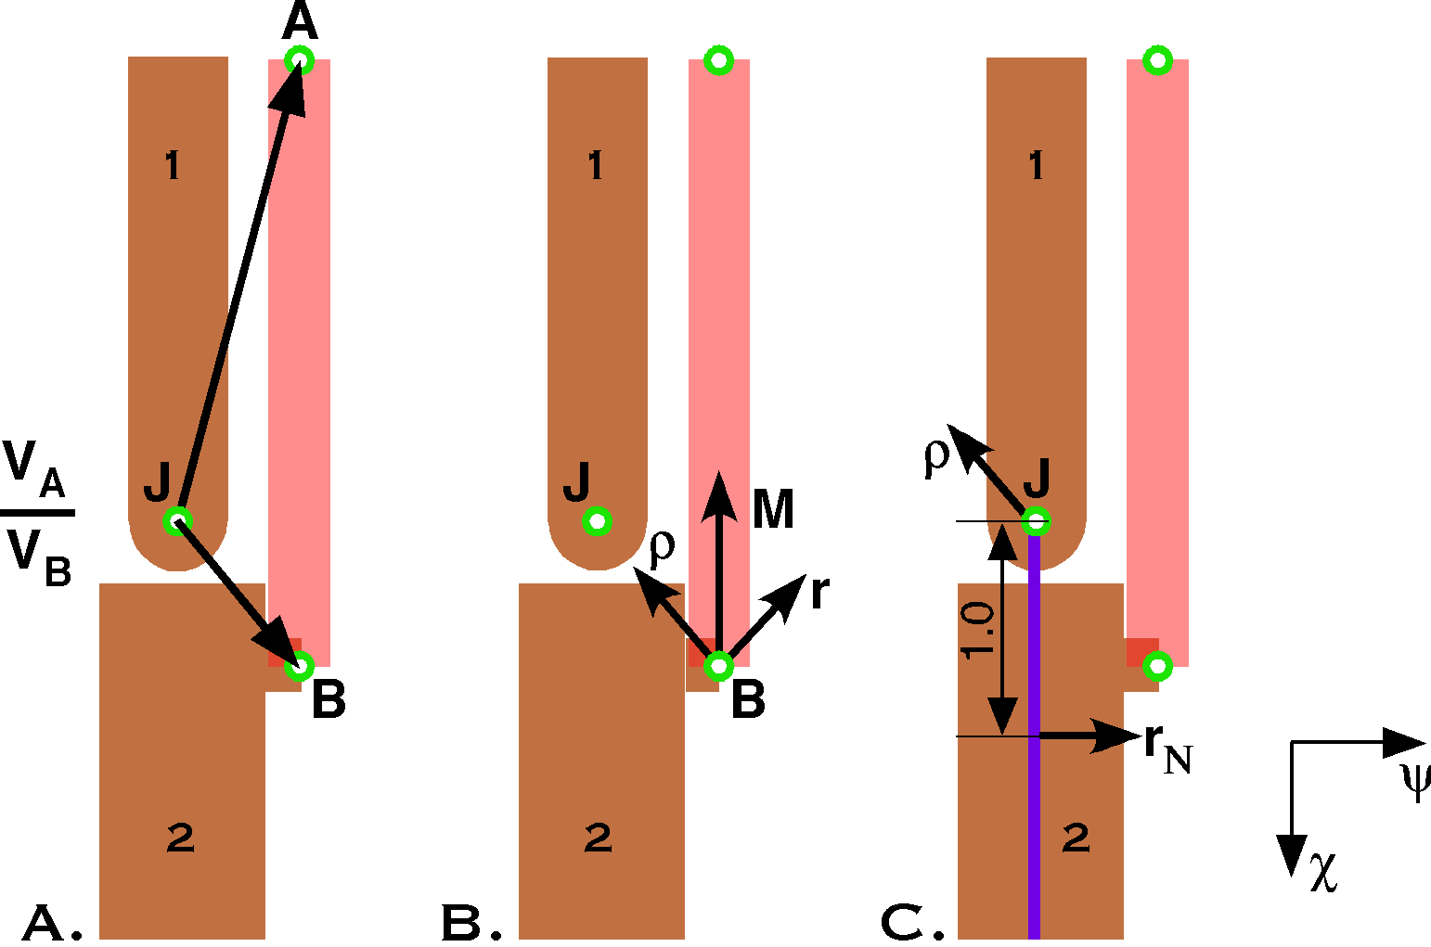

A muscle pulls on a tuberosity on Bone 2 to move it upon Bone 1. A. the functional joint, the origin, and the insertion are illustrated along with the vectors from the functional joint to the origin and to the insertion. The muscle moment is the ratio of the vector from the joint to the origin to the vector from the joint to the insertion. B. The muscle effort is resolved into radial and rotatory force components. C. The force components of the muscle effort are replaced with an equivalent pair of vectors, which are the muscle momentum evaluated at the joint.
The normalized rotatory force expresses the tendency of bone 2 to rotate about the functional joint, that is, about the vector of the moment of the muscle, . It is a scalar equal to the ratio of the length of the rotatory force vector to the length of the lever arm times the unit vector in the direction of the axis of rotation.

Combining Muscle Momenta
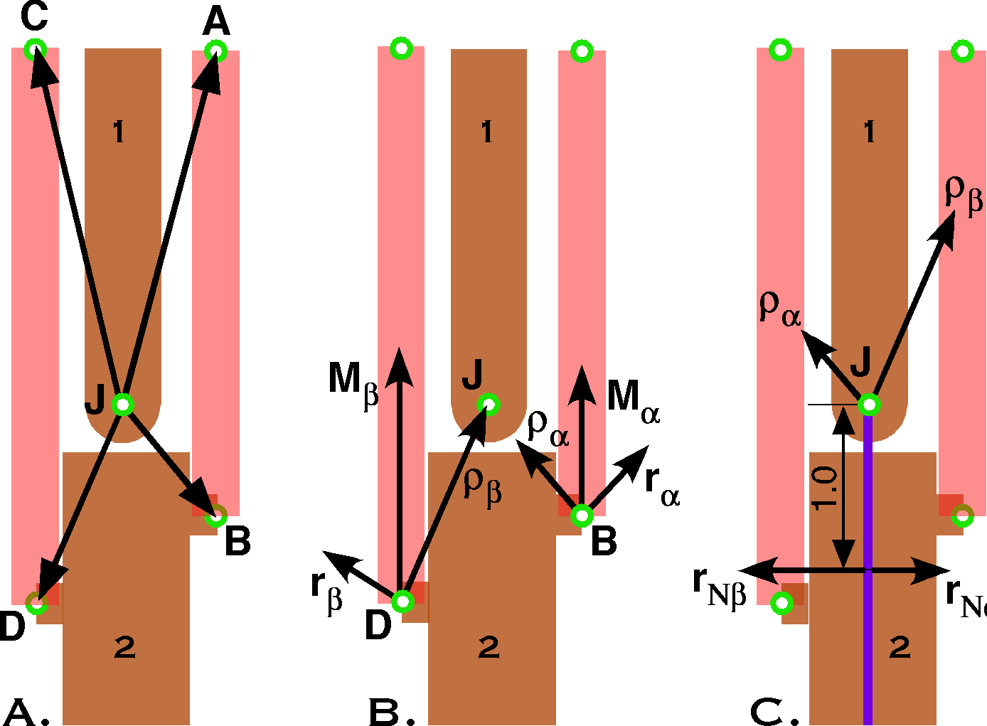

The combination of muscle actions requires that the muscle momenta be recast so that they are all operating at the joint. The radial forces add according to the standard rules of vector addition. The rotatory components also add by vector addition, but they are all expressed as multiples of vectors in the same plane.
Now we can consider the situation where we have several muscles acting across a joint, each with an instantaneous axis of rotation, , an effort, , and an angle of action . We can the write a contraction moment for each.
The resultant of all the muscles actions will be the sum of the muscle contraction momenta.
We can break the combined muscle momentum into two parts, the radial and rotatory components, both of which operate at the joint, but in different ways.
Normally, the movement will change the axis of the muscle moments and a new expression for the movement will have to be computed. Therefore, the momentum is a continuously changing entity that is contingent upon the current muscle set and determining future muscle sets in a musculoskeletal system.

Problems With Muscles Working on Swing Joints
Most of the examples that will be considered here will be quite simple. We will start with examples in which the muscles are in direct opposition and then move on to more complex situations where combined contractions of muscles change their turning vectors.

Axes of Rotation for Anatomical Joints
For many joints there is a single axis of rotation that is enforced by the anatomy of the joint’s articular surfaces and the tethering of the ligaments about the joint. The knee joint between the femur and the tibia is set by the two condyles, which make the joint surface essentially cylindrical, even though the individual condyles are ovoid. The movement is constrained by the collateral and cruciate ligaments. The humero-ulnar joint in the elbow is also cylindrical, because of the helical articular surface, which is locally saddle-like. Ligaments about the joint and the radio-humeral joint prevent much rotation about the trochlea of the ulna. Normally, saddle joints permit rotation about two separate axes of rotation, which lay on opposite sides of the articular surface, but mediolateral swing is blocked by the structure of the elbow joint.
The gleno-humeral joint has a nearly spherical surface, as does the trochanter of the femur. Therefore there is a great deal more variation in the axis of rotation, which depends upon the placement of the humeral head relative to the glenoid fossa or the trochanteric head relative to the acetabulum. Since both are universal joints, the range of the axis of rotation is largely constrained by ligamentous tethering and abutments with nearby structures.

A Simple Example: One Muscle at a Substantial Distance from the Joint
Now that we have laid out a few definitions and relationships, it is time to consider a concrete example, to see how these factors come into play. The first example is very simple. Assume a single muscle, , the one between the apices of the vertical processes of the two bones in the second illustration of this chapter. Let the joint linkage of bone A be 2.0 units and the joint linkage of bone B be 1.0 unit. The vertical processes are 1.0 unit long and each insertion is at the apex of its process. The framed vector for bone A in neutral position will be as follows.

The framed vector for bone B will be as follows.
The muscle direction is the difference between its insertions, . If the muscle contracts, then its moment is the ratio of its origin to its insertion.

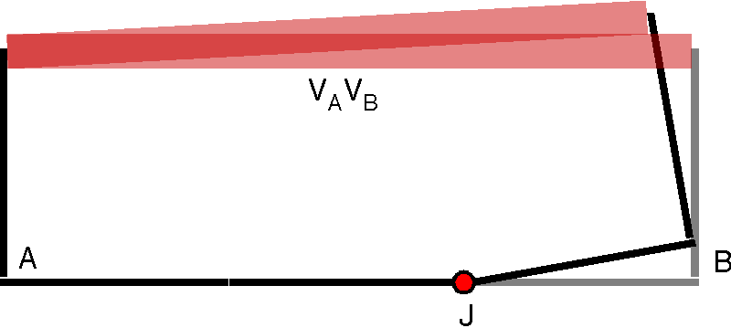

The muscle is attached at some distance from the joint, but with a long lever arm. This combination gives modest movement with moderate contraction and effort.
For a small contraction, the new arrangement of bone B can be computed from the muscle moment and the framed vector of the bone. Let the excursion be 10°.

If you recalculate the muscle moment, you will find that it now has an angle of 98.435° about the +k axis. The muscle has contracted from a length of 3.0 to a length of 2.82. We obtained a 9.25% change in the angle of the muscle moment with a 6.15% shortening of the muscle.
Note that the muscle must contract to a third of its original length in order to bring the link armature of B to a 90° angle with the link armature of A. That is very non-physiological. That is why muscles that attach in this manner do not produce large changes in the angle of a joint. Muscles can in theory contract to about half their length if they start stretched to the point where the sacromere elements are just about to disengage and contract to the point where they are maximally overlapping. Muscles normally work in a much smaller range. Let us consider a more natural arrangement of the muscle with respect to the bones and the joint.
The momentum of the muscle working at the joint is readily calculated. The lever arm is at a 45° angle to the joint linkage for bone B. Therefore, and . The muscle is at an angle of 135° to the lever arm. That leads to the following momentum.

The radial force at the joint is compression at a 45° angle away from the muscle insertion and a rotatory force about the axis of the muscle moment. The radial force is about 0.7 times the rotatory force.

A More Natural, Still Simple Example: Muscle Crosses Joint Near the Joint
Let the attachment site on bone A be about 0.1 units along the vertical process and the attachment site upon bone B be about 0.1 units beyond the joint on the link armature. The framed vector for bone A in neutral position will be as follows.

The framed vector for bone B will be as follows.

The direction of the muscle is the difference between its insertions, . If the muscle contracts, then its moment is the ratio of its origin to its insertion.
The great majority of the muscle, about 20/21, is on the A side of the joint. The muscle subtends almost 180° relative to the joint and the axis of rotation is in the positive k direction.

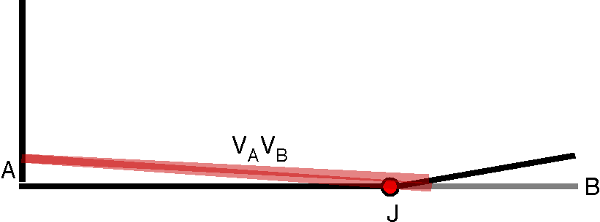
The muscle is attached in such a ways as to operate close to the joint and to have a long belly. This combination produces large movements with small contractions.
For a small contraction, the new arrangement of bone B can be computed from the muscle moment and the framed vector of the bone. Let the excursion be 10°, as is the previous example.
If we do the calculation, then the result is the following framed vector for bone B.

If you recalculate the muscle moment, you will find that it now has an angle of 167.138° about the +k axis. The muscle has contracted from a length of 2.1024 to a length of 2.1001, a difference of 0.1%. We obtained the same movement as in the first example with a much smaller contraction. A little thought will reveal that the linkage for bone B can be taken through 90° of rotation about the joint by shortening the muscle to a length of 2.0, which is slightly less than a 5% contraction. A 10% contraction will rotate bone B through almost 180°.
In general, placing an insertion near a joint and another insertion at some distance will produce large angular excursions with small muscle contractions. Being near the joint, such muscles must pull harder than more distant muscles to produce the same movement. We will see that a large fraction of the effort is going into compressing the joint. The relative magnitudes of the scalar and vector components of the contraction moment reflect the relative fractions of the effort that is going into compressing or distracting the joint versus rotating the joint.
The momentum of the muscle working at the joint is again readily calculated. The lever arm is at a 0° angle to the joint linkage for bone B. Therefore, and . The muscle is at an angle of 177.27° to the lever arm. That leads to the following momentum.

The radial force at the joint is compression along the axis of bone A and a small rotatory force about the axis of the muscle moment. The radial force is about 21 times the rotatory force. This arrangement is not as efficient way to rotate bone B on bone A. Most of the effort goes into compressing the joint.

Insertion Offset From the Axis of the Bone
Let us consider a slight anatomical modification to the last arrangement. Place the insertion on a tubercle that extends 0.1 units away from the shaft of the joint linkage process. The framed vector would be as follows.
The efficiencies of the last arrangement are retained in that small contractions produce large angular excursions. Let us consider the momentum. The expression is a mixture of the previous two expressions. The lever arm is at a 45° angle to the joint linkage for bone B. Therefore, and . The muscle is at an angle of 135° to the lever arm. That leads to the following momentum.

The radial force at the joint is compression at a 45° angle to the axis of bone A and a small rotatory force about the axis of the muscle moment. The radial force is about 7 times the rotatory force. This arrangement is about three times as efficient for rotating bone B on bone A when compared to the last arrangement. Still, most of the effort goes into compressing the joint, but we are getting a substantially better proportion going into rotating the joint, which is normally the desired consequence of the muscular effort. If we move the tubercle closer to the joint, then the efficiency of the muscle in rotating the joint increases. If the tubercle is adjacent to the joint, then all the effort goes into rotating the joint. (). Consequently, we tend to get maximal efficiency in turning a bone in a joint if we place the muscle insertion near the functional joint, on the side of the muscle.

Contrary Efforts
Next let us consider two muscles that act at the same joint, but in opposite directions. Let the first be the muscle that we have just considered and the second be its reflection across the joint. The framed vector for bone A in neutral position will be as follows.

The framed vector for bone B will be as follows.

The muscles are then the difference between their insertions,
If the muscle contracts, then its moment is the ratio of its origin to its insertion. We may readily compute both muscle moments. The difference is the direction of the turning vector.
The combined muscle momentum is the weighted sum of the two component muscle momenta.

If the efforts are equal, then the combined momentum is compression along the shaft of bone A, because the component momenta cancel each other. The limb does not move, but the joint is compressed with a force that is twice that generated by each muscle. If the efforts are not equal then the joint will rotate, because there is a non-zero rotatory force.
The momentum is composed of two components, a radial component and a rotatory component. If one of the efforts is zero, then the combined momentum becomes equal to the remaining effort. When both efforts are the same, the rotatory component becomes zero and the two radial components add vectorially.

Opposing Forces
If and are the muscle moment axes of two muscles that act in direct opposition to each other, as in the situation that we have just considered, then their combined action may be to hold the limb in a single placement or to move the limb in the direction of one of the moments . If the two moments are not in direct opposition, then there is a combined muscle moment that is not aligned with either muscle moment vector .
Pairs of muscles may work cooperatively to move the bones about an intermediate axis; thereby creating a virtual muscle that behaves differently than either component muscle alone. The next few sections will consider a few musculoskeletal systems that do not have the muscles in direct opposition and therefore are able to move the swinging bone about an axis different from the axis of any muscle in the set. These are more interesting, because they allow the bones to move in a wide range of directions.
The simplest such systems are those that have three non-coplanar muscles. In such systems pairs of muscles can act together to create virtual muscle with any axis of rotation in the plane of the two muscle axes that can be expressed as the positive sum of the two axes of rotation. Muscles can only pull, so, negative coefficients of the axes of rotation are not permissible. The third muscle can oppose all virtual muscles formed by the other two. By taking different pairs of muscles, one can create axes of rotation in a full circle of directions.
We will find that three muscles generate geodesic trajectories, but the moving bone can attain only orientations that have null spin relative to the starting orientation. In order to reach other trajectories, one must have at least one more muscle.

Three Opposing Muscles with Muscle Moments in a Single Plane
Let us return to the original diagram of the musculoskeletal system and consider the muscle moments of the three muscles that link the apices of similar processes (V_{A}V_{B}, R_{A}R_{B}, and L_{A}L_{B}). Let the processes be one unit long and the linkage processes be one unit long as well. Then we can write down the frames for the two bones. The muscle attachments are 120° apart and equally far from the center of the bones. Therefore, we can write the framed vectors by inspection.

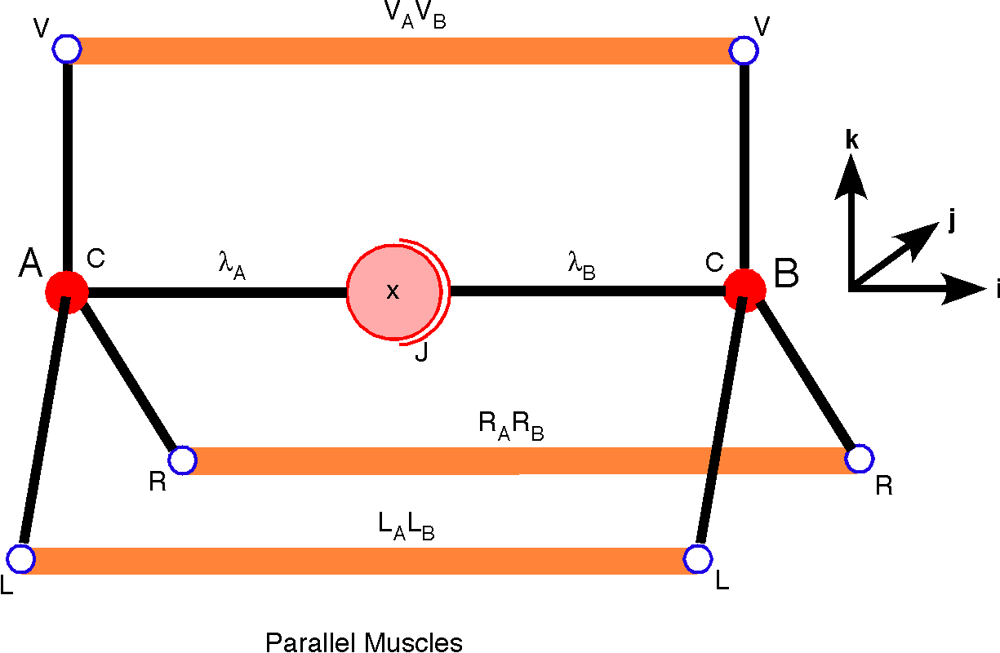

The muscles that join similar vertices are illustrated. They are capable of rotating bone B along geodesic trajectories from neutral position, which is shown here. Equal co-contraction of all three muscles will compress the joint.
The direction of all the muscles is , but the vectors of the axes of rotation are rotated relative to each other by 120°.
All the axes of rotation are in the same plane, a vertical plane through the joint. Clearly, any combination of actions in these three parallel muscles must also lie in that plane. In a system of three opposing muscles that have all of their muscle moment vectors in the same plane the system is stable in that the resultant muscle moment vector lies in the same plane.
All of the trajectories that are generated by these muscles are great circle or geodesic arcs for the shaft of the bone. The orientation of the moving bone is determined by the initial orientation and the direction of the arc.
The three lever arms are the hypotenuses of right triangles, so we can write down their directions and magnitudes and the angle between each lever arm and its muscle is 135° in every case. That information is sufficient to allows us to write down the combined momentum.
We can now massage this equation, simplify, and re-arrange the terms to obtain a more useful form for our purposes.

This is a complicated formula, but some examination will reveal that it has the expected symmetries. Setting any two efforts equal to zero gives the momentum of the third muscle. If all three muscles contract with equal force, then the bone will not move, because the sum of any two will be the opposite of the third. The joint will be compressed in the direction of the shaft of bone A with a force that is one and a half times the contraction forces, .
The axis of rotation is always in the j,k-plane, perpendicular to the shaft of the joint linkage for bone A. Because all the axes of rotation are confined to the same plane, all the rotations are geodesic trajectories that retain null spin relative to the orientation of bone B in neutral position. The orientation of bone B is determined by its position and the neutral orientation.
If the muscles are not parallel to the joint linkages of the bones in neutral position, then the trajectories are not geodesic, because the three axes of rotation are not is a single plane, but the orientation of bone B is still determined by the position of the bone. We will consider such a situation next.

Three or More Muscles with Muscle Moments Not in a Single Plane
Let us now consider a second set of muscles, the muscles that extend from one process to the next process in a clockwise direction (V_{A}R_{B}, R_{A}L_{B}, and L_{A}V_{B}). These muscles are illustrated in the following figure. We could equally well use the ones that are next in a counter-clockwise direction. The framed vectors are the same as in the last section. So, we can readily compute the muscle directions.
First we define the muscles.

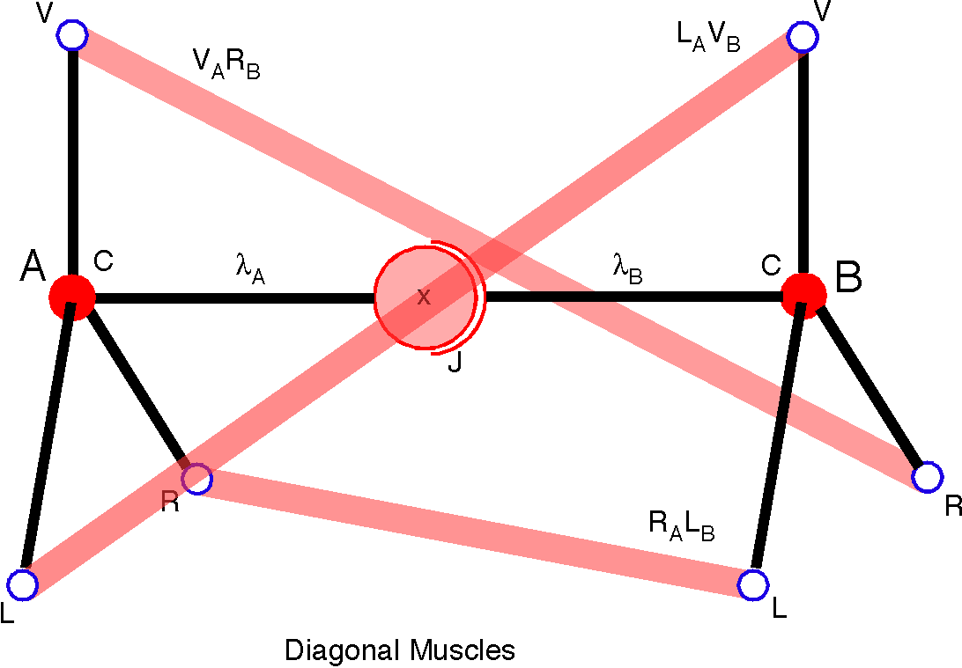

Three diagonal muscles are illustrated. They connect each process to the next process in a positive direction, if the rotation axis is directed towards the joint. These muscle configurations will rotate Bone B in an oblique trajectory, when viewed end-on or from the side. Consequently, they do not produce geodesic trajectories in either of those frames of reference and they impart a twist to the orientation of the bone. When all three muscles co-contract with equal force, they cause bone B to rotate about an axis aligned with the linkage process to the joint.
If we convert to contraction moments and sum the three muscle contractions the result is as follows.
If each muscle makes the same effort (), then the contraction moment simplifies to an interesting expression.
We can compute the muscle contraction momentum much as we did in the last example. In fact, some of the parameters are the same. The lever arms are exactly the same as in the case with parallel muscles. We have to recalculate the angle between a lever arm and a muscle by taking the ratio of their vectors.
Each muscle independently will cause bone B to make an oblique rotation, but, working together, they cause the bone to spin on its axis. The rotation is about the axis that extends through the links and the joint.
The final expression is written in that form because the two terms are describing two different forces. The first says that there is compression along the axis of bone A equal to about 1.98 times the effort of each muscle and the second term says that there is a rotation about the axis of the bone with an effort about 1.13 times the effort of each muscle. Bone B rotates about the axis of the linkage with bone A in the direction that will bring process R of bone B into alignment with process V of bone A.
This is a fairly difficult computation to obtain a result that we can obtain with a bit of intuition, however, the power of the approach becomes apparent when we do not choose a situation with such symmetry of effort. It is not difficult to write a program that incorporates the basic approach that has been illustrated here and use it to compute the trajectory of the bones under any stated conditions. All that is required is a statement of the placement of the two bones with the extensions for the muscle attachments and the definition of the muscles in terms of their attachments.
By spinning about its axis, the insertion sites upon bone B move into alignment with the insertion sites on bone A. In all positions short of alignment, the muscle directions are tilted in three oblique directions, but the sum of the contractions always generate a contraction moment that is in the direction of the i axis. Eventually, the axes will become aligned and the muscles will be parallel, as in the previous example, the axis of rotation will become the null vector, and the force of contraction will be totally compression of the joint.
As bone B is rotating through the 120° to bring it into alignment with bone A, the muscles that were parallel are stretched as they move into a diagonal alignment, the opposite of the alignment of the diagonal muscles that we started with. Consequently, by a suitable choice of the lengths of the parallel and diagonal muscles one may obtain any orientation in a 120° arc.

It Takes Three Muscle Pairs or Six Axes of Rotation to Reach All Placements
With three muscle moments, there are placements that one cannot reach. For the situation with the parallel muscles it was possible to reach only those placements that were on great circles from the initial placement. In fact, most placements are impossible to achieve with only three muscles. In addition, since muscles cannot exert negative effort, there are many locations that cannot be reached.

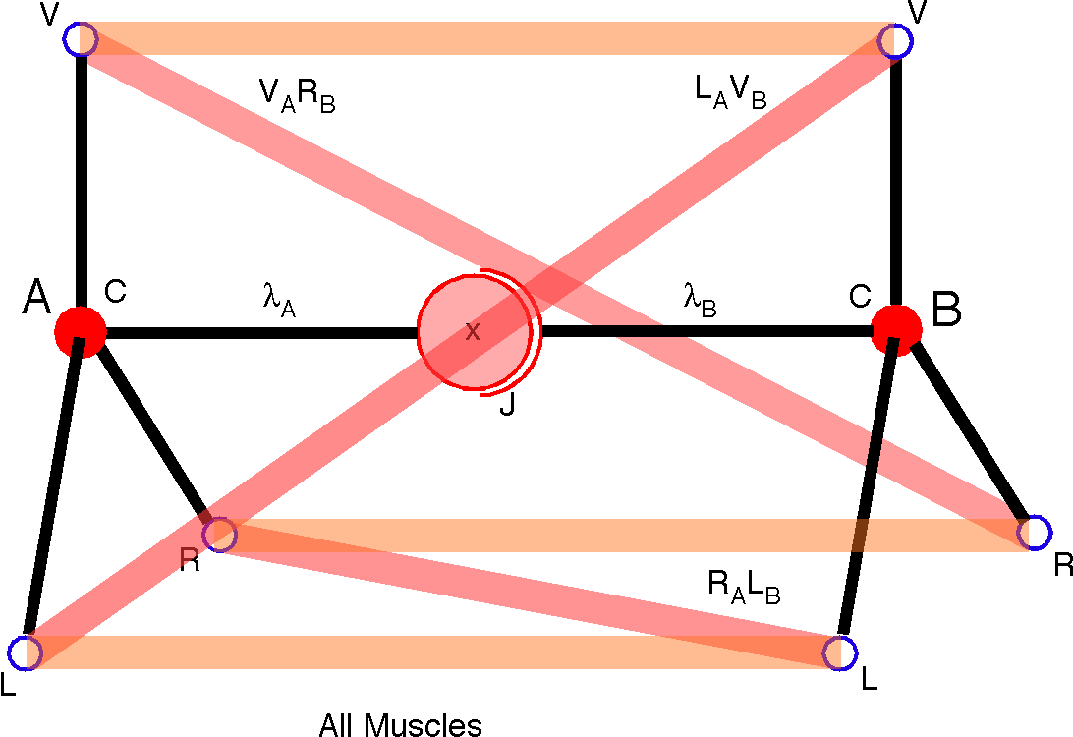

All the muscles are illustrated with bone B in neutral position. With all six muscles, it is possible to control the location and orientation of bone B. Shortening the diagonal set of muscles will lengthen the parallel set, so that with 60° of rotation one has two diagonal sets of muscles with opposite sense. With 120° of rotation, the diagonal set becomes a parallel set and the parallel set becomes a diagonal set with the opposite sense.
Muscles cannot have negative moment vectors. Therefore, one often sees three opposing pairs of muscles to produce rotations in all directions. Three opposing pairs or six vectors are sufficient to generate all placements. More generally, six non-coplanar vectors allow for full independent control of placement (location and orientation). For instance, the bone may be rotated until it has the desired orientation and then moved along a geodesic until it is at the desired location. By pairing muscles one may create parallel muscle equivalents.

Muscle Sets that are Able to Determine Placement
A bone can rotated to a location by two coplanar unit moment vectors and then a third moment vector that travels with the bone can be used to rotate about its axis to obtain the desired rotation. The process can be reversed by setting orientation and then location.

Most Movements Continually Change Muscle Moments and thus Contraction Moments
As the bones rotate, the muscle insertions rotate relative to each other, which means that their moments change.
For instance, if the diagonal muscles shorten then they rotate bone B upon bone A and make the parallel muscles shift from coplanar to tetrahedral while the diagonal muscles shift from tetrahedral to coplanar. By partially rotating the bones relative to each other, we can effectively create parallel muscles by combining pairs of muscles. Because of this phenomenon, it is possible to rotate bone B until it is spin neutral to its final placement, then use the virtual parallel muscles to rotate it along a geodesic trajectory to the final location.
Adjacent muscles will have directions on opposite sides of the geodesic plane. Therefore adding them in correct weightings will produce a vector in the geodesic plane.

The Geometry of Axes of Rotation Determines the Nature of Permitted Movements

Parallel Muscles Produce Geodesic Movements; Non-aligned Muscles Produce Conical Rotations
For any combination of three non-aligned muscles that have an effort greater than zero in every muscle, the resultant contraction moment vector is not in the plane of any pairs of muscle moment vectors. If the three muscles are aligned, that is parallel, then their contraction moment vectors must be coplanar, which means that the trajectories that result from their co-contraction are geodesics for that rotation plane. If the muscles are not aligned or, equivalently, they have non-coplanar muscle moment vectors, then the trajectories are not geodesic for any of the planes of any pair of muscle moment vectors, unless one muscle is not contracting. There will be a twist in orientation as the bone moves. In kinesiological vocabulary, there will be a non-pure swing. If one of the three muscles is not contracting, then the range of possible trajectories is restricted to those that have axes of rotation in the plane of the two remaining muscle moment vectors, between the vectors, that is, the vectors that may be expressed as a positive vector sum of the two muscle moment vectors.
This is equivalent to stating that three independent vectors form the basis of a three-dimensional space, except that, since muscles contract, only positive sums can exist. Consequently, only the convex space bounded by the planes determined by each pair of vectors contains possible moment vectors.

Spin and Swing are Relative Quantities of Movement
It should be noted that any rotation in which a reference point on the moving object remains in a plane may be expressed as a geodesic rotation by choosing another reference point relative to the object. For example, as the earth rotates, the city of Saskatoon, Saskatchewan, traces out a conical rotation. From the point of view of Saskatoon the Earth is experiencing a conical rotation. However, a city on the equator is experiencing a pure swing and the north and south poles are experiencing pure spin. In our current situation, we can truthfully and meaningfully say that bone B will experience a conical rotation under the stated conditions, but we should always keep the thought in the back of our mind that there is a context in which the movement might be seen as a pure swing or a pure spin. The implication for our present considerations is that the moving bone will experience a concurrent twisting rotation as it moves. That is why the wording is so careful and complex in the previous paragraph.
Any conical rotation can be expressed as the product of a pure spin and a pure swing. Elsewhere, we illustrated a protocol that will always give two component movements that combine to give the same outcome as the conical rotation (Transformations of Orientation: Revisiting Swing and Spin). Similarly, we can argue that it takes six independent muscle pairs to guarantee that a muscle set will give any placement within a given range. The pairs need not actually be paired, but it should be possible to generate six independent movements. The reason for pairs is that muscles can only contract, so, if one is to move in both directions along a line of action, then it is necessary to have muscles to pull in both directions.
In the chapter about the movements of the eyeball (Transformations of Orientation in a Universal Joint) there were six muscles, therefore the eyeball could potentially be placed in all placements in a continuous region of the placement space. It was noteworthy that functional constraints reduced the actual range to the placements with null spin relative to neutral gaze.

Co-contraction of Muscles Will Produce Intermediate Actions

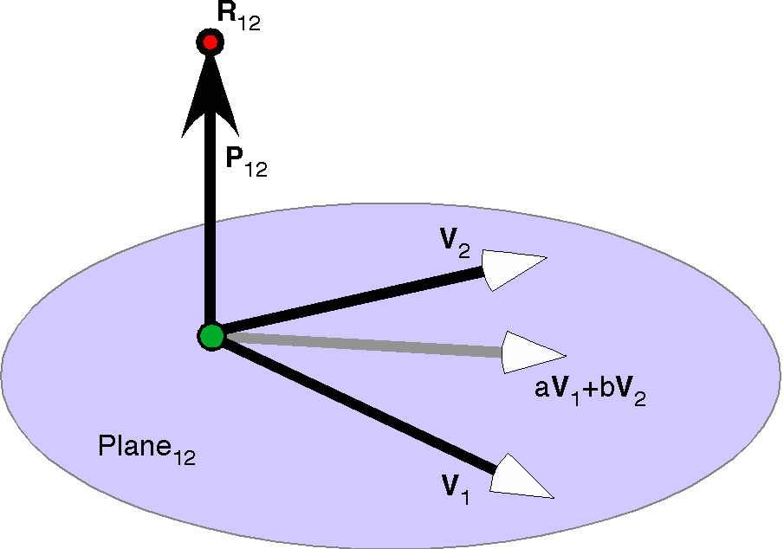

The two muscle moment vectors, V₁ and V₂, determine a plane and a perpendicular vector P₁₂. Any reference point, R₁₂, on P₁₂ will experience geodesic rotations when rotated about V₁, V₂ or any combination of both vectors. Muscles may combine to form virtual muscles that have muscle moment vectors that are positive linear combinations of the muscle moments vectors, aV₁ + bV₂.
By the co-contraction of pairs of muscles one may obtain virtual muscle alignments that are intermediate to the alignments of the muscles. In the case of the three parallel muscles, we were able to obtain any trajectory that was a geodesic through neutral position. The plane for the three parallel muscles is the geodesic plane for neutral position. That is to say that if the location of the bone in neutral position is taken as the reference point then all the rotation that are generated by combinations of the muscle actions will be great circle that passes through the bone’s location in neutral position.
More generally, if we have two vectors, they define a plane and if we take a reference point on a line that passes through the center of rotation in the direction of the ratio of the vectors or its negative, that is, upon a line perpendicular to the plane defined by the vectors, then the movements produced by those muscles will produce geodesic movements of the reference point. Those movements will have an axis of rotation that may be expressed a positive sum of the muscle moment vectors. In the case of the parallel muscles, the three muscle moment vectors were all in the same plane and each pair was able to produce a sector. The three sectors comprise the entire set of possible directions, therefore the three parallel muscles are able to generate geodesic movements through neutral position in all possible directions.

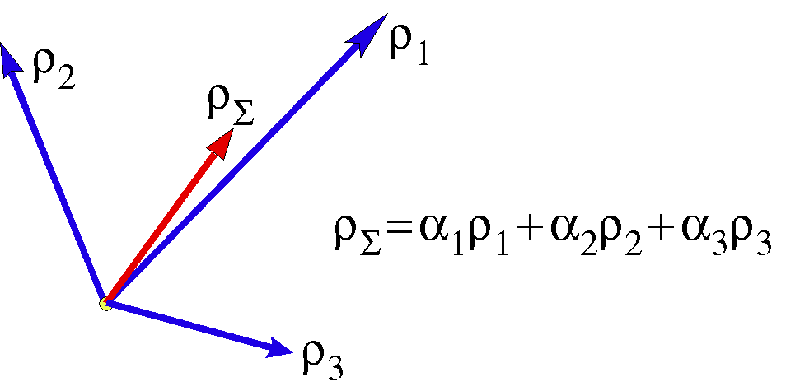
The axis of rotation for three muscles pulling together lies in the region between the axes of rotation for the individual muscles and it is a weighted sum of the individual axes of rotation.
When the three muscle moment vectors are not coplanar, then the possible combined contraction moments vectors will lie in the sector that is defined by the three directions. There is no single reference point, other than the center of rotation that is on the perpendiculars to any two muscle planes, therefore, there is no reference point that will experience geodesic rotations for two different combinations of the muscle contractions. Consequently, at a deep level, the rotations produced by muscles with non-coplanar muscle moments are conical, non-geodesic, rotations.

Four Turning Vectors Reach All Locations, Six Reach All Placements
It turns out that if we have four non-coplanar muscle moment vectors, then we can take them in triplets to generate four sectors that completely exhaust the possible muscle moment vectors. One can see this by allowing the three muscle moment vectors to point to the vertices of a tetrahedron. The movement vectors that are positive sums of the triplet will pass though the face defined by the three elements of the triplet. Each triplet defines a face of the tetrahedron and the four faces of the tetrahedron form a complete closed surface. Therefore, all possible muscle moment vectors can be expressed as a linear positive sum of the four muscle moment vectors.
In practice, we generally do not need to be able to move to all possible locations, only locations in a sector of space, therefore, theoretically, can make due with three non-coplanar axes of rotation.
All possible rotations have been accounted for so four unaligned muscles would be sufficient to move any anatomical object from any location to any other location on the surface of a sphere. They would not be sufficient to move the anatomical object to a particular location with a particular orientation.

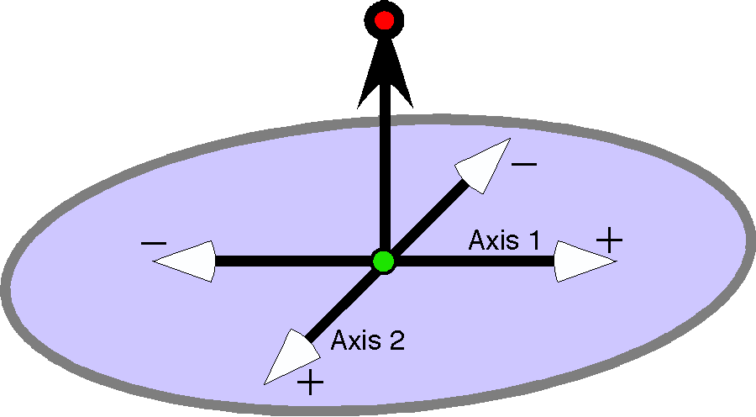

Four muscle moments determine two rotation axes. All rotations are geodesic rotations from neutral position. Orientation is always null spin relative to the orientation in neutral position.
Generally, we wish to move through a sector, therefore a set of three muscles will be sufficient to move an anatomical object to any location in that sector. However, it is possible to choose two pairs of muscles such that each pair has opposite muscle moment vectors and the different pairs have differently oriented moment vectors. The four recti of the eyeball are an example of such an arrangement. Since we have only two effective axes of rotation, all movements in such a system will be geodesic, with null spin relative to neutral position.
For rotations that change location, there are only two dimensions (up/down, right/left). The third dimension would be depth or radial distance and it is not possible to change it with a rotation in a single joint alone. In a system with two joints, radial distance may be a variable. If we add another axis of rotation, aligned with the vector of the plane of the other two axes, then we can change orientation.
In a one joint system, that is all the control that is possible for the modification of orientation. Consequently, a single joint system has a maximum of three independent dimensions of placement. With a two joint system, one may obtain the full six dimensions of placement. An eyeball in its orbit is a single joint system, so it needs only six muscles. If we view eye movements in the context of a moving head, then there are two joints and location and orientation each have three dimensions.
One may see how to control both location and orientation in a single joint system by imagining a system in which one may move a bone by rotating it about its shaft until one reaches the desired orientation and then moving the bone along a geodesic trajectory. Alternatively, one may move the bone to the correct location an then rotate it about its shaft to obtain the desired orientation. With such a system one can obtain all possible placements within the bounds set by the muscle and bone geometry. One might imagine a set of four aligned muscle that move the bone up and down and from side to side and two muscles that rotate it about its axis.
Note that it is not necessary for the muscle moment vectors to be orthogonal or parallel. It only helps to see the actions of the system when such is the case. For instance, the six muscles that control the eyeball are not orthogonal. Each muscle contributes to varying degrees to both swing and spin of the eye, depending upon the placement of the eye. The details of these interactions are complex, but not in principle different from the system of mutually orthogonal muscle pairs considered here.

Joint Action Spaces Generally Have Reduced Action Dimensions and Fixed Relationships Between Location and Orientation
Even though the eyeball has the potential for a relative independence between the orientation and the location of the eye, it does not use that freedom, because there is a functional constraint upon the eye to maintain the visual image of the world upright upon the retina. Consequently, if we know gaze direction, we know gaze orientation. In brief, orientation is spin neutral relative to neutral gaze. A system capable of three degrees of freedom uses only two. In fact, there is reason to think that the eye can use all three degrees of freedom when trying to view a world tilted relative to vertical. The eye is rotated about its line of sight to partly compensate for the tilt. The same type of compensatory correction occurs if one tilts one’s head when looking at a scene. However, that is a wrinkle that we will not address here.
Many musculoskeletal systems reduce their potential degrees of freedom when performing their normal actions. For instance, most bones do not have independent control of location and orientation. Often, as with the eyeball, there is a functional covariation of location and orientation, where knowing the location gives a good estimate of orientation. Another way in which anatomical movements may be more restricted is when certain directions of movement are prevented by bone architecture. For instance, in the ulnar-humeral joint, the trochlear facet restricts the movements to essentially one dimension. The ulna follows a shallow helical trajectory, which is responsible for the phenomena of carrying angle. In isolation, the ulnar-humeral joint does have the potential to rotate the ulna about its long axis, but that does not happen because of ligamentous tethering and abutments with other bones.
In the temporomandibular joint there is also normally a single dimension of movement, essentially back and forth along a bony ridge, but the jaw has a complex trajectory with respect to location and orientation, because changing location leads to an intricate sequence of orientations that rotate the jaw. It is further complicated by the joint having two widely spaced facets, on either side of the mouth.
In fact, there are probably very few joints where there is relative independence of location and orientation, such as the gleno-humeral joint of the shoulder and the trochanteric hip joint. Even those joints tend to have a certain orientation associated with a particular location, but we can move some distance away from those usual placements, if we so choose. In a therapeutic setting, it is common to move the joint into the unused parts of its potential movement space, in order to stretch muscles and/or connective tissue. Sometimes a joint moves into an abnormal parts of its movement space as a result of externally imposed forces.

Neural Control of Placement
Because of the geometry of many joints, there is not a simple relationship between location and orientation and we seldom move along a single dimension in natural movement. When we reach for a cup, our shoulder is changing its direction and orientation together in a complex manner. The intricacy of such movements is good evidence that we do not represent movements in terms of location or orientation, but in terms of placement. The most efficient movements are probably ones that move on smooth, comparatively simple, trajectories in placement space.
In our analysis of the movements of the eyeball, the most efficient movements were not the shortest trajectories in location space or orientation space, but they are conical rotations that change both at the same time in a well defined manner.

Non-muscular Forces

Inertial Forces
Not all the forces acting across a joint are due to muscle contractions. We will briefly consider two other types of forces. The first are the inertial forces, due to accelerations. These come in two basic varieties those due to gravity, the weight of the limbs, and those due to acceleration of parts of the musculoskeletal system relative to other parts. The inertial forces are usually expressed as the mass of the part concentrated at the center of mass or the center of inertia. Other impressed forces may be expressed as a force applied at a particular point.

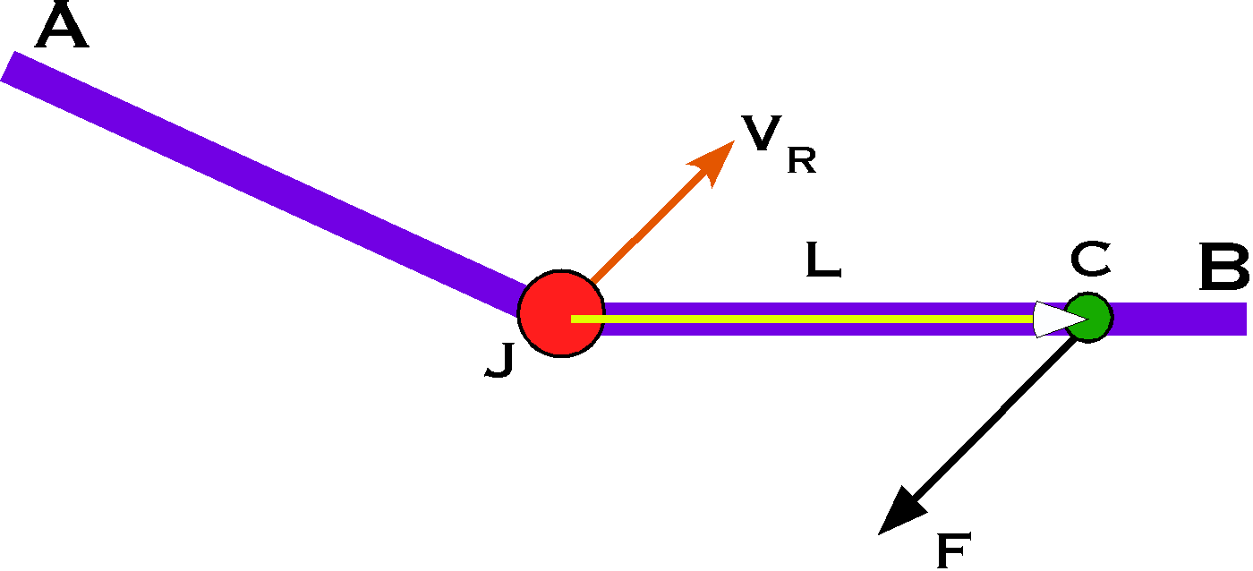
Bone A articulates with bone B in joint J. A force F is applied to bone B at point C. The force will cause a compression at the joint in a direction opposite to the vector from the joint to the point of contact, L = C – J, and rotation about an axis that is mutually perpendicular to both L and F.
The force F is applied at a point C on bone B. The point of application is separated from the joint, J, by a vector L. We can compute a unit vector in the direction that is the ratio of F to L.
We can write down the momentum of the applied force as was done for the muscle momenta.

Tethering and Abutment
The second type of non-muscular force is the resistive force associated with tethering and abutment. Joints are usually stabilized and constrained by ligaments that tether the joint, not allowing two points on different bones to separate by more than a fixed distance (). There may be some stretch in the ligament, but usually very little, because the purpose of a ligament is to restrict movement in certain directions.
Abutment is often associated with tethering, because the tethering forces articular surface together by restricting rotation. Two surfaces come into abutment when they are forced together and they cannot move any closer. Two articular surfaces may not occupy the same region of space (). Once again, there is often some give, but generally not much.

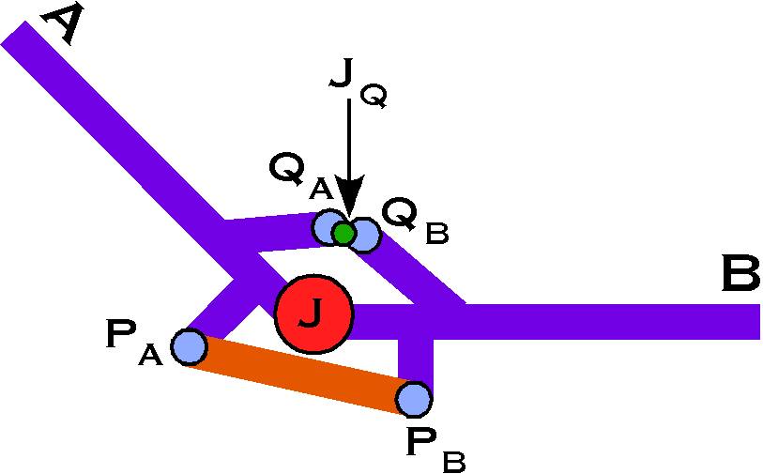
Tethering occurs when points on two bones become separated by a distance equal to the length of the tether. Abutment occurs when two points on different bones have the same location.
Both of the situations create a passive force in a structure or structures that resists further movement. The force generated is the sum of the active forces from muscle contractions and the inertial forces from the weight of the limbs and the loads being moved as they apply at the attachments of the ligament or the contact in an abutment. The two anatomical structures work in similar and different ways.
Both do not enter into consideration until a condition is met. For the tether, there is no force until the ligament attachments on different bones move a certain distance apart. At that point further separation is not longer an option. Depending upon the organization of the ligament with respect to the joint, the movement may be limited in certain directions, but not others. There are always some options for further movement. Generally, ligaments allow the bone to swing in an arc about each other. However, movement in certain directions may be blocked by abutment and the joint becomes fixed and cannot bend further in that direction.
In the knee, the arrangement of the lateral and medial ligaments and the cruciate ligaments is such that one can move into a close-packed position at the end of knee extension with a fillip of rotation to lock it in place. The ligaments restrict the direction of movement and abutment prevents the knee from extending beyond a certain point. However, reversing the terminal rotation allows the knee to be bent.
The lumbar intervertebral discs are constructed so that the intervertebral ligaments allow a certain amount of rotation and rocking between the vertebrae, but they firmly stop all movements beyond that measure. The facet joints operate primarily by abutment. The two together control movements between vertebrae.
While abutments tend to compress the joint by forcing the articular surfaces closer together, they also tend to open joints, by forming an alternative articulation or fulcrum. The functional joint may suddenly move to a new location, which may be dangerous, if unanticipated. The muscle forces are arranged about the joint so that they are in balance for a particular fulcrum. If the fulcrum suddenly changes, the forces that the muscles must bear may suddenly change and a muscle will be overstrained before it can react to protect itself. Other structures about the joint may be forced to assume strains that they were not meant to deal with, leading to tearing of their fabric. Many joints seem to combine ligaments and potential abutments so that the ligament is in place to prevent the abutment or to take the strain if and when it occurs. Muscles are not good candidates for that role, because they take time to react to strain and they may be excessively stretched before the compensatory response can be mounted.
Abutments also experience a passive strain that depends upon the various forces operating about the joint. The forces can be calculated by computing the combined momentum with the join at the point of abutment, rather than at the usual functional joint.
The following chapter considers the manner in which ligaments and abutments restrict movement. To consider those points here would take us away from the general themes developed in this chapter and make this chapter too long. It is too long already, so we will wrap up and consider a new set of ideas in a fresh chapter.

Pulling It Together
It should be obvious that only certain combinations of muscle lengths can occur in any given musculoskeletal system. As some muscles shorten, others must shorten or lengthen as well. These relationships are implicit in the rigidity of the bones and the constancy of the muscle insertions relative to the bones. That relationship between the lengths of the muscles and the bones that they link across joints is the muscle set.
A little thought will reveal that the muscle set is a surface. For every value of the placement of the bones, there is a unique set of muscle lengths. Generally, the surface will be more complex than our usual experience of two dimensional surfaces in a three dimensional space. The independent variable is placement, which may be one dimensional, as in a hinge joint, three dimensional, as in a universal joint, or six dimensional, as in linked universal joints. Placement may have even more dimensions, when we are considering a system with multiple joints. For instance, the lower cervical spine has six independently moveable sets of joints () with two independent axes of rotation. Each bone can change its location and its orientation relative to its neighbors.
Each muscle in the muscle set adds a dimension. For instance, the eyeball has six extrinsic muscles, therefore six dependent dimensions. It has two placement dimensions, therefore the muscle set surface is a two dimensional surface in an eight dimensional space. The number of placement dimensions is the number of dimensions for the muscle set surface and the sum of the placement dimensions and the muscle dimensions is the muscle set space.
We are using independent and dependent in a formal sense, because, in practice, we manipulate the muscle lengths to move the bones. Placement is a function of the muscle lengths. However, changing the placement of the bones changes the muscle lengths. Each reflects the other through the relationships that we are calling muscle set.
The muscle set is the surface of permissible muscle length combinations plotted against the bone’s placements. It is generally not possible to visualize such a space, but there are tricks that allow us to get some insight into the structure of such a space. They compromise some of the features and preserve others.

Contour Maps of the Muscle Set Space
One such trick is to construct a contour map. When we want to illustrate a geographical region in terms of all of its ups and downs, we often resort to a contour map. The procedure usually involves computing the curves that have a constant height in the landscape, a set of concentric lines on a flat sheet of paper. On occasion, we want to illustrate how the elevation varies along vertical slices through the landscape and we stack the boundaries of the slices in a horizontal projection upon a flat vertical surface.
With a muscle set, it is often convenient to slice the surface so that it is projected upon a surface perpendicular to the axis for a muscle. In the instance of the extrinsic eye muscles it was convenient to slice the surface in the directions of the individual muscles. It gave us a set of six contours that could be plotted against placement, which has only two dimensions for the eyeball. Consequently, we could plot the projection of the surface for each muscle, a stack of six curvilinear planes (see the initial figure in this chapter). However, what is shown is a contour map of a two dimensional surface in an eight dimensional space.

Dimensionality of Muscle Set Spaces
In general, the dimension of the surface is the number of independent placement dimensions. In the instance of the eyeball, or any universal joint, there are effectively three degrees of freedom, medial/lateral, elevation/depression, and rotation about the line of gaze. The first two give the location or gaze direction and the third give the orientation. However, because of functional constraints embedded in Donder’s and Listing’s laws, orientation is determined by gaze direction. Consequently, there are only two independent placement dimensions. It is usual for the anatomy of a joint to introduce constraints on the number of independent placement dimensions for a system.
In general there is a dimension for the muscle set space for each muscle, but that too can be altered by the anatomy. If we start with a strict hinge joint, then the placement has a single dimension, joint angle, and there is a muscle or set of muscles the moves it one way and another muscle or set of muscles that moves it in the opposite direction, but if we know the value for one, then we can calculate the length of the other muscle. The muscle set space has two dimension, one for joint angle and one for the length of one muscle or set of muscles. If we have multiple muscles pulling one or both directions, that would not fundamentally change the situation.
That does not mean that there is not interesting anatomy in such a joint. For instance, one muscle might be attached so as to be efficient is getting the joint moving at an extreme position. A second might be arranged so as to give power when the joint is in another placement. The supraspinatus and deltoid muscles operate in this manner when abducting the arm at the gleno-humeral joint in the shoulder.

Different Dimensional Muscle Set Surfaces
As stated above, another way in which muscle set surfaces differ from our common image of them is that they may be one dimensional, as in the example of a hinge joint that we just considered. They may be two dimensional, as in the case of the extrinsic eye muscles. They will usually be three dimensional for universal joints and they may be higher dimensional where the placement has more independent dimensions.
If we wished to consider the placement of a hand while reaching from a fixed body, then the muscle set surface would be six dimensional. We are warranted in calling a six dimensional surface a surface because it has fewer dimensions than the muscle set space in which it is embedded. In the hand placement example, there might be dozens of muscle dimensions. There could easily be a dozens muscles involved in the shoulder alone.

Collapsing Muscle Set Spaces
A little thought will lead one to realize that in the last example one of the remarks made at the start of this section no longer holds. The muscle set surface is no longer unique to the placement. We know that if you grip a stationary pole, thereby fixing the placement of your hand, and without moving your body, you are able to move your arm and forearm through a substantial excursion. Those movements change the lengths of many of the muscles in the muscle set, because the muscle attachments are moving relative to each other as the bones move relative to each other. It is obvious that the muscle set surface is not unique to the placement of the hand. That is because we have collapsed the full muscle set space. If we introduce the placement of the scapula, humerus, radius, ulna, and the carpal bones, then the muscle set surface is unique. The space is also much larger.
We can collapse muscle set spaces by projecting the full surface into a smaller number of dimensions, much as sunlight shining through shear curtains will create shadows where multiple layers of curtains exist at the same point in the shadow.
Collapsing muscle set spaces is not a bad thing. It reflects reality. We frequently have an array of ways to accomplish an action and we can choose among those options for the one that best suits the constraints on our movement. Sometimes the constraints are externally imposed, as when reaching into a confined space. Sometimes the constraints are internally imposed as in getting a grip for twisting the pole or pulling oneself towards the pole. Usually it is a combination of external and internal constraints that the nervous system has to address in generating the movement. Consequently, it may be fortunate that there are many options from which to choose. We may choose the one that is optimal to the occasion. We may change our choice if our muscles become tired in one configuration. We may choose an optimum after some experimenting, as a precision athlete does when training and practicing to perform a jump or twist or a dancer does when finding a graceful movement.

Elegance and Grace of Movement
There are movements that are judged to be elegant solutions of the problem just considered. We commonly find ways of moving more efficiently to achieve a particular outcome. When a person moves efficiently, we say that they are graceful. When a movement lacks efficiency then it is said to be clumsy. It is probable that elegant or graceful movement will turn out to be efficient in the sense that it traces a geodesic trajectory in the muscle set surface, that is a shortest path between two states. However, the most graceful trajectory may be an optimal path subject to constraints.
When considering eye movements we found that the trajectories that will move the eye between gazes and ensure that it is correctly oriented when it arrived is a particular type of geodesic in the muscle set surface for the extrinsic eye muscles. In that case, it was not the shortest possible path, but the shortest path subject to the constraint of automatically correcting orientation. When that path is not followed, the eye movement is inefficient and clumsy in that it requires a correction movement to achieve its goal. Taking a shorter path would force one out of the muscle set surface.

Movement Depends Upon a Combination of Muscle Set and Combined Muscle Momenta
Muscle actions are specified by a combination of the muscle set as expressed in the muscle set surface and the interactions of the muscle momenta. The muscle set surface constrains the possibilities and the geometry of the musculoskeletal system to direct the trajectory taken in that surface. Clearly the muscle set is determined by the geometry of the system, but there is still a multitude of ways that the muscles may co-contract to move the system in that surface. When muscles contract or relax, they change their axis of the movement and produce results that none alone is capable of producing in isolation. The muscle set surface means that as some muscles contract others must also shorten or lengthen; which ones change and how determines how the system will move or be stabilized. All these factors are combined in the combined muscle momentum, which expresses the direction of movement in the muscle set surface. Tethering and abutments may also prohibit many configurations.
The muscle set determines the placement of the bones and muscles, which are expressed as a point in that surface. The various muscles working across the joint create a combined muscle momentum that has a vector component that specifies the direction of movement for the next bit of the trajectory. The new placement changes the configuration of muscle and bones, which starts the process over again. In fact the process is continuous and the result is a trajectory in the muscle set surface.
This analysis raises the obvious question of how the trajectory is determined by the nervous system. As discussed above, it is likely that the chosen trajectory is a geodesic in the muscle set surface, subject to certain constraints. The nervous system in some sense follows a path of least effort.

Invariants and Muscle Set Surfaces
In science, we often look for invariants, that is, parameters that remain the same during apparent change. In physics, it was discovered that energy was constant in closed systems, collisions between perfectly elastic objects conserve linear momentum, and a spinning body conserves angular momentum. In chemistry, we expect the mass of the products of a reaction to be the same as the mass of the constituents that went into it and we expect the numbers of atoms of each element to be the same before and after the chemical transformation.
Similarly, when we scan our world, we find that it is filled with many entities that remain essentially the same whether we move or the object moves, such as chairs and tables. Even a friend is perceived as being a continuing unity despite many changes in their location and their postures, how we are viewing them, and where we are. We are able to recognize a chair whether it is near or far, upright or tilted on its side, in bright light and dim light. It is the same chair if we view it face on or see it out of the corner of our eye. These mental constructs are invariants of a sort. They remain essentially the same through great changes in their apparent appearance. Extracting such invariants from the clutter and chaos of our experience is something that brains do very well and computers do very poorly. It is thought that the basis of such discrimination is a continual conversation between the elements of communities of neurons and between such communities, which are feeding information forward and backward in massive networks.
In addition to such perceptual invariants, there are motor invariants. We do not consider all the details of our muscles and joints when we reach for a cup of coffee. The reaching is, in a sense, an invariant that encapsulates the task that needs to be done. We use multiple levels of neurons to translate that concept into the actual muscle contractions and joint movement necessary to place our hand at the correct location with the correct orientation to grasp the cup. If the cup is nearer or further, if we have to reach around an obstacle, if we are wearing a heavy coat or are bare armed, if we are sitting upright or lying down the task is much the same at the level of the reaching.
You may have noted that forces are not a central concern in the analysis that we have been considering. That is because they are highly contingent upon the specific condition in which the movement is occurring. They are critical to successful accomplishment of a movement, but we would never represent the movement in terms of the individual muscle forces. The movement that we wish to accomplish is much more efficiently stored as a trajectory in a muscle set surface. That is especially true if we need only enter the starting point and the finishing point and the surface automatically generates the trajectory. Then that trajectory can be translated into actual muscle forces by low level circuits that lie in the brainstem and spinal gray matter. Automatic compensation can be made for the weight of the arm and the posture of the body.
It should be clear from the analysis that we have been engaged in that the control of movement is an incredibly difficult computational task. Far beyond what the human nervous system is capable of in real time. Obviously the nervous system does not care about quaternions. They are a convenient way for us to describe and analyze movements, but not a way to organize the nervous system. However, it is fairly straightforward to create neural networks that embed the muscle set surfaces in their connectivity. It is largely a matter of practicing until we are able to perform the task to criterion in a wide range of situations. Basically the way that one learns to skate, shoot baskets in basketball or to drive a car. The problem with such a mechanism is that it is very difficult to understand in detail, because the task is a distributed property of a number of collections of neurons that massively interact with each other. It may be impossible to understand what is happening by examining the neurons one-by-one. In any case, we will not try to deal with the problem at the level of individual neurons. We will work with the invariants for the movement, the muscle set surface for the musculoskeletal system.

